Carina Cricket Club 2025/2026 – Batting, Bowling & Wicketkeeping Skills & Drills

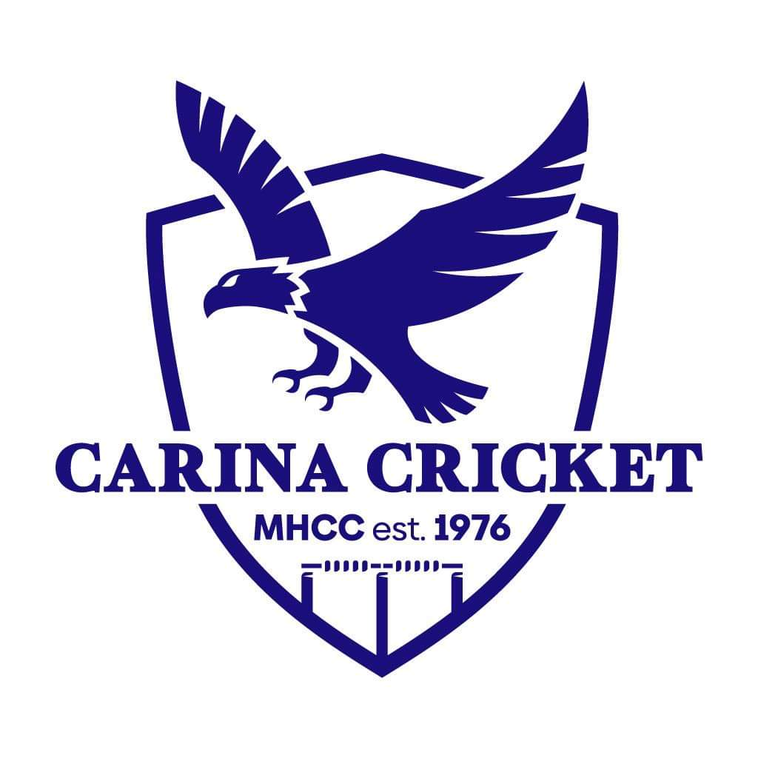

Batting Coaching Guide

How to teach batting?
Batting is a key fundamental skill in the game of cricket, with the main aim of batting being to score runs, and therefore set the team up to win the game or chase down an oppositions total.
When teaching a young player how to bat the following steps to follow are recommended:
- Teaching players how to hold the bat and what stance is required. https://youtube.com/shorts/GNHXQukTMjg?si=bsA_2pZP_7rvbY1p
- Getting players comfortable hitting a ball with a cricket, key coaching points are watching the ball, being stable (one step), and full bat swing, therefore, a lighter bat is best for beginners. Does not need to be straight bat at this stage. https://youtube.com/shorts/W4v0KemKxy4?si=ESCY5bOPOjcPWWPi
- Teaching batters to hit in different directions, footwork, head position, and different swing planes, straight, offside and leg side. Introduce the concept of straight bat. All front foot at this stage. https://youtube.com/shorts/vxy50h_YJuI?si=jb7VioNy3ZJ_Igx1
- Teaching players to hit along the ground and defend the good balls (introduces decision making). All front foot at this stage. https://youtube.com/shorts/NtNUNP2GCCI?si=hBrUKCBGR_Gn7D3P
- Teach players to use back foot. Pull shot, back foot drive, cut shot.
- Teach players to find singles (soft hands), twos and boundaries off the bad balls (fast hands), hitting the balls at different levels of power, and hitting gaps.
- Teaching players to play spin (include skills of advancing and sweeping). https://youtube.com/shorts/uOdKK0_yTpA?si=DVfz4UU2V1Hp30nN
- Teaching players to hit sixes (power hitting). Video
- Teaching players to adjust against swing bowling. https://youtu.be/1G2g2dt2LvM
- Teaching players to asses the situation of the game and play accordingly.

Consolidation and repeated practise of each of these steps is recommended throughout all junior age groups.

Grip and Stance
Grip - Top hand firm, loose bottom hand, hands together. Vs (as seen in video) go down the back of the bat.
Stance – Side on, toes facing point fielder, (front foot slightly further back ), feet shoulder width apart, eyes level, head still.
https://youtube.com/shorts/GNHXQukTMjg?si=bsA_2pZP_7rvbY1p
Batting Technique
Front foot – Eyes to the ball, step forward with front, bent front knee for weight transfer, head over our toes, back leg stable and straight, contact the ball under our eyes with a straight bat, follow through, extending our arms through the shot, stay balanced, one solid step into to the ball. Shorter step for one drive so leg doesn’t get in the way of the bat, head needs to be slightly forward of front foot.
Front foot defence – Forward Defence
Front foot drives – https://www.youtube.com/shorts/_txfhwLPyqg?reload=9&si=t-06R-fbEgMapPi4

Leg stump front foot drives – https://youtube.com/shorts/a8lxUZYhscY?si=MjhKcLHEFlBfArtY

Back foot straight bat – Feet back and across, weight on back foot, eyes behind the ball, play the ball close to out body, extend hands through when driving, keep hands soft when defending.
https://youtube.com/shorts/0v61ol1Ghj8?si=T38J_u2WYPZUIVWu
Pull shot – Weight transfer on back foot, extend arms, fast hands, eyes on the ball, can swivel after we play the shot, hit the ball as hard as you like.
https://youtube.com/shorts/o--VklI-IkY?si=pT-gw8WEYhQyJDrw
Cut shot – Feet back and across, head across to the ball, contact the ball as it passes your back hip, extend arms through the ball (don’t overuse wrists), follow through over your shoulder, stay balanced after the shot. Late cut is the same except you place the bat there rather than extend arms through the ball.
https://youtube.com/shorts/0IiLIMzyudI?si=bq1DEaaD6Ps4mclX
Back foot glance – Feet back and across, weight on back foot, eyes behind the ball, play the ball close to out body, align front hip with the ball, extend hands through when driving, keep hands soft when defending.
https://youtube.com/shorts/p7OXrOLmdFM?si=HZCltH_sI7c5-tcW

Power Hitting
- Transfer weight forward or back.
- Head and eyes going towards the ball.
- Stable base.
- Full bat swing.
Video – https://youtu.be/1G2g2dt2LvM
https://youtube.com/shorts/d9Bp99O3pB8?si=n3a0aDQnOxdcEnxr

Playing Spin
- Play the ball before it spins, big stride out to the ball (drive the ball if full enough), OR play the ball after spins, deep in crease let it spin and play if off the back foot, use back foot shots stated above. Don’t want to get stuck in between.
- Move forward or back based on where you think the ball will land.
- Have more time to decide whether to go forward or back so use it, in order to help make the right decision.
- Can use advancing down the wicket or sweep shots when needed if the bowling is consistent and you’re struggling to score.
Playing spin – https://youtube.com/shorts/uOdKK0_yTpA?si=DVfz4UU2V1Hp30nN
Advancing down the wicket – https://youtu.be/1G2g2dt2LvM
Sweep shots – https://youtu.be/cF0RsFlnifo

Advanced Skills
Playing swing bowling – Move later as we don’t want to commit to the first line we see, play the ball under our eyes, head over the ball, soft hands when defending, hit with the swing slightly. Aim mid-off for out swing, aim mid on for inswing.
https://youtube.com/shorts/Jv8Z1b5UVwc?si=Gq3zrXZqwNCPQsHJ
Finding quick singles – Soft hands, adjusting our contact point to access different areas, i.e. hit the ball really late to have the ball go behind square, no where the gaps and be bale to drop the ball in those gaps by using soft hands and wrists, run hard and call loud.
Play seam bowling – Head right over the ball, must commit forward or back, can’t get stuck in between, soft hands when defending. Attack the full and short balls.
https://youtube.com/shorts/Jv8Z1b5UVwc?si=Gq3zrXZqwNCPQsHJ

Running Between the Wickets
How to run:
Loud calls – yes, no or wait. No calls like ‘run,’ ‘no run’ or ‘yeah mate.’
Run hard.
When turning; look in the direction the ball is, get low and reach out to place your bat over the line.
When sliding your bat; reach out, used the edge of your bat to slide along the ground, don’t run too far past the stumps.
Golden rule – whenever we run, always be ready to run another as overthrows are very common in junior cricket and batters can take advantage of these mistakes from fielding teams, DO NOT run too far past the crease, as you may not be able to take advantage of an overthrow.
Note; if the ball hits the stumps when you are in and the ball ricochets away, you are ALLOWED to run, if fielder throws the ball and it hits the batter and ricochets away, you are NOT ALLOWED to run, it is against the spirit of the game, and at Carina we always want to uphold the spirit of the game.
When to run:
Batters need to judge whether they can make it to the other end, factoring in where the ball is, the quality of the fielder and the speed of the batters. Comes with practise.
When running an additional run, a good guide to use is whether the fielder has picked up the ball or not. Only a guide.
Backing up - https://youtube.com/shorts/zQmpcrwg9t4?si=d9kWq32ifA1ZLWZE
Turning - https://youtube.com/shorts/ok-M1J-LW2s?si=BQSw3yTJFwe7JqMY

Batting Game Plans
Standard game plan – Need to score but no need to take unnecessary risks. Work with players identify what’s a good ball and what’s a bad ball, encouraging players to attack the bad balls, and defend the good balls.
Shorter format game plan – Need to score faster whilst still minimising risks. Attack the bad balls, be ruthless, find singles off the good balls, running between the wickets becomes important here.
Back end of an innings game plan – Score as many runs as we can. Power hitting skills. Consider which areas to target based on where the field is placed. If fielders are back, may only gets 1s or 2s in that area, and target other areas for boundaries.
Batting Drills
Front foot batting:
- Moving to the ball - https://youtube.com/shorts/zdkT0LIqHPg?si=RBLCPzDlLaoAjVzu
- Avoiding backing away - https://youtube.com/shorts/ZH6DQkEzGQQ?si=PQNmVAYJaYKz6P0e
- Playing straight - https://youtube.com/shorts/ZH6DQkEzGQQ?si=PQNmVAYJaYKz6P0e
- Weight transfer on front leg - https://youtube.com/shorts/MypMh6jXQZY?si=ljQ9EOJeqFkMUOQG
- Balance drills - https://youtube.com/shorts/MypMh6jXQZY?si=ljQ9EOJeqFkMUOQG
- Position for leg side - https://youtube.com/shorts/a8lxUZYhscY?si=MjhKcLHEFlBfArtY
- Keeping our weight forward and over the ball - https://youtube.com/shorts/NtNUNP2GCCI?si=hBrUKCBGR_Gn7D3P
- Staying side on.
- Top wrist strength.
- Drop ball feeds.
- Underarm feeds.
Front foot drills - https://youtu.be/des2RnaHsuo

Back foot drives:
- Moving back and across
- Transferring weight onto the back foot.
- Getting behind the ball.
- Playing close to our body.
- Staying side on.
- Underarm.
- Throw downs.
Back foot drive drills - https://youtu.be/Kyx-DaslZ6Y

Pull shots:
- Weight transfer.
- Confidence.
- Extension of the arm.
- Not rotating hips too early.
- Fast rotation of the hips.
- Increase reactions.
- Batting tees.
- Underarms.
- Throw downs.
Pull shot drills - https://youtu.be/Kyx-DaslZ6Y
Cut shots:
- Back and across
- Transferring weight on the back leg.
- Head position.
- Hands drills.
- Not falling back.
- Contact point.
- Batting tees.
- Underarms.
- Throw downs.
Cut shot drills - https://youtu.be/HKQQyJ_aHpU
Back foot glance:
- Moving back and across
- Transferring weight onto the back foot.
- Aligning front hip with the ball.
- Playing close to our body.
- Underarm.
- Throw downs.
Back foot glance - https://youtube.com/shorts/p7OXrOLmdFM?si=HZCltH_sI7c5-tcW

Playing spin decision making drill – https://youtube.com/shorts/uOdKK0_yTpA?si=DVfz4UU2V1Hp30nN

Advancing down the wicket - https://youtu.be/1G2g2dt2LvM

Advancing drills:
- Getting down the wicket drill.
- Moving to the ball drill.
- Balance drill.

Sweeping progressions:
- Hitting of a tee.
- Hitting from a strike position.
- Underarms.
- Throw downs.
Slog sweeps:
- Hitting from a strike position.
- Underarms.
- Throw downs.
Sweeping Overview – https://youtu.be/cF0RsFlnifo
Hitting gaps - https://youtube.com/shorts/vxy50h_YJuI?si=jb7VioNy3ZJ_Igx1
Decision making - Need to make video
Hitting along the ground: Square drill – have a square around the batters, and task the batter with ensuring the ball bounces in that square after every shot, can even be two bounces for defensive shots, encourage batters to play powerful shots, whilst ensuring the ball bounces in the box. https://youtube.com/shorts/NtNUNP2GCCI?si=hBrUKCBGR_Gn7D3P
Finding singles – Need to make video
Running Between the Wickets:
Backing up RBW - https://youtube.com/shorts/zQmpcrwg9t4?si=d9kWq32ifA1ZLWZE
Turning RBW - https://youtube.com/shorts/ok-M1J-LW2s?si=BQSw3yTJFwe7JqMY

Balance: https://youtu.be/phGmrkYkavU?si=G9ZsLfGN_CpSEsof

Mindset of Batters
Confidence:
Trust our skills, work hard in the nets and work on weaker areas, to ensure we can trust that our skills will serve as well on game day.
Positive body language.
Surround ourselves with positive teammates, as coaches, we can help ensure we have a positive team environment.
Dealing with fear of getting out:
Recognise that getting out is OK and happens to all players.
Place importance on having fun and learning.
Have a process-based focus rather than an outcome-based focus. Focus on what we have to do, not the negative outcome.
Dealing with fear of being hit by the ball:
Practise weaknesses (i.e. the short ball) to gain confidence. Repetition, repetition, repetition.
Have a process-based focus rather than an outcome-based focus. Focus on what we have to do, not the negative outcome.

Fast Bowling Coaching Guide

Pace Bowling Technical overview

Ball grip – Two fingers on the seam, thumb underneath on the seam, loose grip otherwise body tenses up if grip is tight. Wrist flicking down with fingers running behind the ball, this ensures a straight seam with the ball revolving backwards as it travels towards the batter.
https://youtube.com/shorts/Ev1mcfGARUo?si=fBpQ4eM0gF0jtNYz

Run up
- Natural running motion (elbows back and leaning forwards).
- 70-80% intensity, not too slow as there is not enough momentum, not too fast and then the bowler is off balanced at the crease.
- Natural stride length.
- In a straight line towards our target. Elbows driving backwards and upper body leaning forwards.
- Ensure we are accelerating and building momentum as we approach the crease.

https://youtube.com/shorts/eywallua83o?si=-zEhKTMcmyyZLdwl

Gather (take off)
- Jumping forward not straight upwards.
- Jumping in a straight line.

https://youtube.com/shorts/u9EQjimYg5A?si=5H8hJV1Ofr1y7wAG

Back foot landing
- Back foot feet aligned with take-off foot.
- Stable back leg.
- Head aligned with our back foot.
- Front arm touching the sky (the positioning based on our type of action).
- Bowling arm hand in front of our back hip with the wrist cocked.

Type of action - Three types of bowling actions; front on, side on, semi open, which is based on how our back foot lands at the bowling crease. The way we land with our feet is natural, however, it’s our top half that we need to follow what our feet does otherwise we run the risk of potential injuries.

- Front on action = open shoulders, front arm just on the outside of our eyes (uncommon that bowlers have a front on action, but some do, I always explain it for the purposes of understanding the bowling action).
- Semi open action (45 degrees) = shoulders semi open, front arm in front of our eyes (most common action).
- Side on action = shoulder side on, front arm on the inside of our eyes.

https://youtube.com/shorts/hfGSp4CyG4E?si=m-O0InaFhVKODyOM

Front foot landing
- Front foot aligned with back foot.
- Front toe pointing straight.
- As straight (as possible) front leg.
- Head in line with front foot.
- Front arm pointing towards the batsman.

Release
- Front elbow pulling into our side.
- Head and chest driving towards the target.
- Ensure our eyes stay on the target for as long as possible.
- High bowling arm release.
- Wrist behind the ball. Seam should be straight.

Head falling away - https://youtube.com/shorts/V-dhU6NF-ZM?si=SYj9au2RnmxJGba4
Front arm drills - https://youtube.com/shorts/bqkyZUbggKY?si=N_OdrJuNKINV9TY9

Follow through
- Back knee driving forward and through to our target.
- Straight line towards our target with our head and feet.
- Bowling hand goes out to our target.
- Bowling arm down past our left knee.

Follow through - https://youtube.com/shorts/EtD3t_0qfjQ?si=ZY9Ob43jOWp2SVnK

That is a comprehensive overview of the pace bowlers’ action to help coaches identify any areas of improvement, however, when teaching it to juniors you would want to break it down to keep it simple.

Basic Pace Bowling Checklist (more basic overview)

- Ball grip – Two fingers on the seam, thumb underneath on the seam, loose grip otherwise body tenses up if grip is tight. Wrist flicking down with fingers running behind the ball, this ensures a straight seam with the ball revolving backwards as it travels towards the batter.

- Run up – Right speed that allows momentum and balance at the crease, runs naturally, builds up in speed before bowling (no slowing down).

- Alignment – Everything from run up through to the bowling action and then the follow through, is in a straight line towards the target.

- Safe action – Ensure that the type of action is identified, and the front arm position reflects it. I.e., Front on action = open shoulders, front arm just on the outside of our eyes (uncommon that bowlers have a front on action, but some do, I always explain it for the purposes of understanding the bowling action). Semi open action (45 degrees) = shoulders semi open, front arm in front of our eyes (most common action). Side on action = shoulder side on, front arm on the inside of our eyes.

- Front arm – Front arm is strong and used effectively by pulling down into our side as the bowler bowls the ball.

- Head position – Their head is not falling away, it is staying in line with their feet, and then going towards the target. Eyes on the target as we bowl the ball.

- Follow through – Bowler keeps going towards the target in a straight line as they follow through. Aim for 6-10m.

When correcting a bowler’s technique always start from what they do first (the run up) and then work our way through the action to see what the mistake may be.

Common Pace Bowling Mistakes

- Running in too fast or too slow (losing speed). https://youtube.com/shorts/eywallua83o?si=-zEhKTMcmyyZLdwl

- Not running in a straight line. https://youtube.com/shorts/cTk15yVeMjY?si=64ISrSLqxgxA_VWO

- Not jumping in a straight direction. https://youtube.com/shorts/cTk15yVeMjY?si=64ISrSLqxgxA_VWO

- Bowling off the wrong foot. https://youtube.com/shorts/Sjrl-zIeCNs?si=kn4r5dsljqxfdQ_p

- Landing with a collapsed back leg. https://youtube.com/shorts/6FglupltpKQ?si=Hkvhed3sc1mNiQzQ

- Feet not aligned from take-off step, back foot, and front foot. Video

- Collapsed front leg. Video

- Front arm not in the correct position (based on type of action). https://youtube.com/shorts/hfGSp4CyG4E?si=m-O0InaFhVKODyOM

- Front arm too low and not pulling into our side. https://youtube.com/shorts/bqkyZUbggKY?si=N_OdrJuNKINV9TY9

- Head falling away. https://youtube.com/shorts/V-dhU6NF-ZM?si=SYj9au2RnmxJGba4

- Not staying side on at the crease. Video

- Not watching the target when bowling. https://youtube.com/shorts/V-dhU6NF-ZM?si=SYj9au2RnmxJGba4

- Not having a straight and long enough follow through. https://youtube.com/shorts/EtD3t_0qfjQ?si=ZY9Ob43jOWp2SVnK

- Wrist not behind the ball therefore the seam is not straight. https://youtube.com/shorts/Ev1mcfGARUo?si=fBpQ4eM0gF0jtNYz

These (along with others) are some good things to look out for when coaching the bowlers.

Bowling Technique Drills
Run up alignment – Set up a channel of cones, about 1 metre apart, and encourage bowlers to run in between those cones the whole way as they approach the crease. Video

Gather alignment – Use cones once more (can go even tighter than one more meter) to ensure bowlers jump into the crease (gather) in a straight line. Video
Stable back leg drills – https://youtu.be/GpzYqd7ZMZg?si=fxSx1BpZ-wrk-Y_w Video
Feet alignment drills – https://youtu.be/BwHKNGQkGO0?si=WpA0xW3iJ2Uw6XRx Video
Front arm drills and explanation – Practise having another ball (even a small medicine ball) to get a feel of what your front arm is doing. https://youtube.com/shorts/bqkyZUbggKY?si=N_OdrJuNKINV9TY9
Head position drills – Bowl alongside a net to ensure that if we fall away with our head, we hit the net straight away and get instant feedback. When bowling full pitch, you can use agility poles to create a tunnel to stop bowlers from falling away as they’ll hit the walls of the tunnel. https://youtube.com/shorts/V-dhU6NF-ZM?si=SYj9au2RnmxJGba4
Follow through drills – https://youtu.be/XrUx5TU0Jgo?si=PxZyShh4H0tfPjZb , have a channel of cones to ensure alignment, have a target cone to aim towards to ensure long follow through length. https://youtube.com/shorts/EtD3t_0qfjQ?si=ZY9Ob43jOWp2SVnK
Wrist release drills – Throwing practising the wrist release, bowling into a side net practising the wrist release. https://youtube.com/shorts/Ev1mcfGARUo?si=fBpQ4eM0gF0jtNYz

Target Bowling
Where is the ideal place to bowl for different age groups?
U9s, U10s, U11s – At the stumps. Make the batter play as much as possible and bring in all forms of dismissal. Aim to bowl full.
U12s and U13s – Off stump or just outside, make the batter play as much as possible and bring in all forms of dismissal, whilst avoiding the leg side. Aim to bowl full.
U14s and above – Top of off stump to top of 4th stump. make the batter play as much as possible and bring in all forms of dismissal, whilst avoiding the leg side, and a driveable / back foot length. Bowl wider of off stump if needing to be defensive.
Bowling target practice - https://youtube.com/shorts/zjK8FdYJhBc?si=iVxEFBMqr9vm1rKV
Variations
Swing bowling – https://youtube.com/shorts/DQ7pGzqABE8?si=j2zas8WWlKHTxpaX
Slower balls – https://youtube.com/shorts/IVi0PoCkZbQ?si=V7TY073x7yGeOdxK
Cutters – https://youtube.com/shorts/0NxjQ90wLTc?si=czJ65HYBWfL5b_SW for off cutter & https://r.search.yahoo.com/_ylt=Awr91XbnYfhosWkC.k92BQx.;_ylu=c2VjA3NyBHNsawN2aWQEZ3BvcwMy/RV=2/RE=1761137256/RO=11/RU=https%3a%2f%2fwww.youtube.com%2fwatch%3fv%3dIh7tt7sZqCQ/RK=2/RS=eV17OLFnn8vKEPv5A.SsRp7GotA- for leg cutter
Yorkers and Bouncers – https://youtube.com/shorts/0NxjQ90wLTc?si=czJ65HYBWfL5b_SW

Spin Bowling Coaching Guide

Spin Bowling Technical overview

Leg spin grip and wrist action – Two fingers on the seam, thumb underneath on the seam. Use wrist to spin the ball, the back of the hand facing the bowler.

Video – https://youtu.be/Z1qpVTYif3M?si=IdbVJiJeI84Y0nPc

Off spin grip and wrist action – Two fingers on the seam (slightly wider than leg spin), thumb underneath on the seam. Use fingers to spin the ball, the front of the hand facing the bowler.

Video – https://youtu.be/0kH_QwWtF7U?si=SAfFvJVOrJSOzF9a

Run up
- Smooth approach towards the crease, doesn’t need to be long.
- Consistent routine.
- Keep the grip nice and loose and relaxed for leg spin, little tighter for off spin.

Gather (take off)
- Going forward towards the crease.

Back foot landing
- Side on back foot.
- Stable back leg.
- Head aligned with our back foot.
- Front arm touching the sky, we need to be looking on the outside of our front arm.

Front foot landing
- Front foot aligned with back foot.
- Front toe pointing straight.
- Head in line with front foot.
- Front arm pointing towards the batsman.

Release
- Front elbow pulling into our side.
- Head and chest driving towards the target.
- Ensure our eyes stay on the target for as long as possible.
- High bowling arm release (slightly lower for leg spin).
- Wrist action for off spin and leg spin.

Follow through
- Back knee driving up and forward through to our target.
- Pivot on our right leg with our bowling shoulder finishing point towards the target. We should face with our whole body to the left (for a right arm bowler) -LEG SPIN ONLY.
- Finish facing forward towards the batsman – OFF SPIN ONLY.
- Straight line towards our target with our head and feet.
- Bowling hand goes out to our target.
- Bowling arm down past our left knee.

That is a comprehensive overview of the spin bowlers’ action to help coaches identify any areas of improvement, however, when teaching it to juniors you would want to break it down to keep it simple though.

Spin Bowling Key Terms

Flight – How ‘high’ and loopy the ball is as it travels to the batsman, a little bit of flight is good but not too much.
Dip – How quickly the ball drops it’s height, makes it hard for the batsman to play.
Drift – How the ball changes it’s line in the air, makes it hard for the batsman to play.
Turn – The ball changes it’s line after hitting the pitch, makes it hard for the batsman to play.
Bounce – How high the ball goes after hitting the pitch, the more the better.
Have a good drive through the crease, strong action, and ball release will help achieve the above.

Ten Common Spin Bowling Mistakes

- Not approaching the crease in a straight line.

- Collapsed back leg.

- Feet not aligned from take-off step, back foot, and front foot.

- Front arm not in the correct position.

- Front arm too low and not pulling into our side.

- Head falling away.

- Not watching the target when bowling.

- Not having our back leg drive through the crease with our hips rotating through.

- Incorrect wrist release.

- Low bowling arm at release.

*Refer to videos above for assistance on how to fix these mistakes.
Spin Bowling Drills

Gather and approach alignment – channel of cones one metre apart for the bowler to approach the crease through.
Stable back leg drills – https://youtu.be/GpzYqd7ZMZg?si=fxSx1BpZ-wrk-Y_w
Feet alignment drills – https://youtu.be/BwHKNGQkGO0?si=WpA0xW3iJ2Uw6XRx
Front arm drills and explanation – Practise having another ball (even a small medicine ball) to get a feel of what your front arm is doing.
Head position drills – Bowl alongside a net to ensure that if we fall away with our head, we hit the net straight away and get instant feedback. When bowling full pitch, you can use agility poles to create a tunnel to stop bowlers from falling away as they’ll hit the walls of the tunnel.
Driving through the crease drills – Use a hurdle or cones, to drive up and over when bowling.
Wrist release drills off spin – https://youtu.be/EjLVgi_HBus?si=ZC-RZEAcsmrpZjNG
Wrist release drills leg spin – https://youtu.be/CA2PKyOZN7M?si=SVZbnVhBoAozRbs3
Release point drills – Bowl next to a net or with a tunnel of agility poles thus to provide instant feedback if arm is too low.
Flight drills – Have a rope tied across the net and aim to bowl over the rope whilst still keeping a decent speed and length.
Dip and drift drills – https://youtu.be/gcIIoFmhgso?si=xpX29QPskZeEOaTX

Spin Bowling Variations
Leg spin variations – https://youtu.be/cV4CUBI3VYg?si=dnAWyNmS4L4-s83K
Off spin variations – https://youtu.be/3BddzLToyR8?si=qZO-ZrYORF4Jp0iA

Wicketkeeping Coaching Guide

Stance position and gloves presentation:
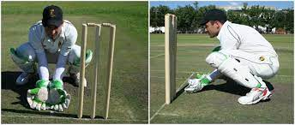
Squatting low, gloves are open, eyes are level and over the gloves. Set up just outside the off stump,
Ian Healy tips; https://youtu.be/rL5QvGAOB9M?si=iDDCKREuD6EPEGub
Adam Gilchrist tips; https://youtu.be/jJLhxzfGo8U?si=eZwy-EYSN1qNZj6e

Keeping back to the stumps:
Head – Eyes level, head over our gloves, eyes tracking the ball into our gloves.
Body height – Start low, rise as the ball bounces.
Footwork – Feet move laterally, aiming to catch the ball on the inside hip, thus, to be covered for any outside edges.
Gloves – Open glove presentation (create a large surface area for the ball), hands out to receive the ball (just in front of eyes), and bring it into ourselves (soft hands), hands working together as one. No crocodile hands. Fingers pointing down or pointing up based on height.

Keeping up to the stumps:
Head – Eyes level, head over our gloves, eyes tracking the ball into our gloves.
Body height – Start low, rise slightly as the ball bounces, aim to stay as low as you can, for as long as you can.
Footwork – Powerful movement laterally, stay on the balls of our feet.
Gloves – Soft hands, fast hands ready for stumping, hands working together as one, large glove presentation for increased surface area for the ball to go in.

Wicketkeeping drills:
https://youtu.be/BNoS1IuR6p0?si=JT8Y3oTc5tH7JxpR
https://youtu.be/Guz4ZtqoiG0?si=X6SMxxwBBvRSyG0Q
https://youtu.be/wPosPr2G258?si=PJ2CFOHmDHv7jyQx
https://youtu.be/jJLhxzfGo8U?si=eZwy-EYSN1qNZj6e

