Carina Cricket Club Junior Pathway

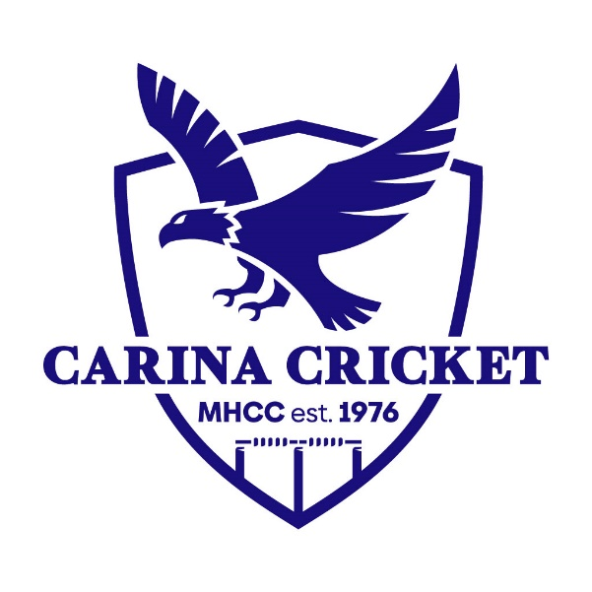
Caria Cricket Club has always aimed to be a club for all, whether you play cricket socially or aspire to reach the highest levels of the game, Carina is the right club for you. This document details the pathway junior cricketers take from Blasters through to playing for Australia or whichever destination they seek in their cricket journey.
BEARS Junior Divisional Cricket U15s
Lords Taverners Competition (Played by Premier Clubs Only)
BEARS Junior Representative Cricket U15s – 1 x QJC, 1 x Development
BEARS Junior Representative Cricket U14s – 1 x QJC, 2 x Development

BEARS Junior Representative Cricket U13s – 1 x QJC, 2 x Development

BEARS Junior Representative Cricket U12s – 1 x QJC, 2 x Development
EDJCA U11s Rep Team
Brisbane Grade Cricket
Senior Club Cricket
BEARS Junior Divisional Cricket U18s

BEARS Junior Divisional Cricket U17s
BEARS Junior Divisional Cricket U14s
BEARS Junior Divisional Cricket U13s

U12s Junior Cricket
U11s Junior Cricket
U10s Junior Cricket
U9s Junior Cricket
Blasters
QLD 2nd XI
QLD sides – U17, U19, U23
Australian Cricket Team

Ron Eager Cup (participation based)
no)

U16 State Challenge. 2 Teams from Metro, 2 Teams from Country.
BEARS Junior Representative Cricket U16s – 1 x QJC,

BEARS Junior Divisional Cricket U16s
QC U17s Train on Squad
Brisbane Metropolitan Competition 50 Overs

QLD U17s

QLD Bulls / Brisbane Heat
Carina Junior Pathway Explained

Blasters
The Blasters program is designed for kids 5-10 years old whom are new to the game and/or below the age / skill level to play U9s junior cricket. Here is where kids learn the basic skills of being able to hit, bowl, throw and catch a cricket ball. They also play small-sided games to understand how a game of cricket works. Blasters is always done with plastic balls with no protective equipment needed. Players hit of a tee when there are wides.

U9s Junior Cricket
U9s Junior Cricket is the first age group of junior cricket. The matches are similar to Blasters in that they are small sided (eight per team), everyone bats an allotment of balls no matter how many times you get out, everyone bowls the same amount, and batters get to hit off a tee for wides. The main differences are the length of games being 20 overs per team, the ball is harder than a Blasters ball hence protective equipment is needed, the pitch is slightly longer and is 16 metres.

U10s Junior Cricket
U10s Junior Cricket is very similar to U9s, key differences are the length of game is 25 overs per team rather than 20, and there are no batting tees, so wides and no balls are not re-bowled and merely counted as a ball faced.

U11s Junior Cricket
U11s Junior Cricket uses a harder ball (142g), has a longer pitch of 18m, and when you are out, you are out. Batters will retire after a certain number of balls faced in order to ensure everyone gets a go, and bowlers will bowl in two over spells, but all will still bowl the same amount.

Eastern Districts Junior Cricket Association (EDJCA) U11s Ron Eager Cup
Named after Carina Life Member, the late Ron Eager, Ron Eager Cup is a week-long participation-based carnival for U11s designed to ready juniors for carnival cricket. They play 40 over matches in quarters from Monday-Friday. Conventionally, we will have a 15-20 player squad so that we can rotate players throughout the week, this ensures more kids get an opportunity and ensures kids have a safe and enjoyable experience with it traditionally being one of the hottest weeks of the year weather wise. Clubs in the EDJCA region take turns of hosting the carnival. The clubs in EDJCA are Carina, Mansfield, Bulimba, Wynnum and Holland Park.

U11s EDJCA Representative Team
Every year clubs get to nominate players to attend the U11 representative trials for an U11s representative team featuring the best XII in the EDJCA U11s age group. The team gets to play in an U13s carnival called the Les Kinnane Cup in Ipswhich in mid-January. Despite the age difference, given these players are quite high level, they are normally competitive with the U13s. The trials conventionally take place in Term 4.

U12s Junior Cricket
U12s Junior Cricket is quite similar to U11s except they use the full pitch of 20.12m, this is the first age group where teams will bowl from both ends.
Bayside East and Redlands (BEARS) Divisional Cricket
Following U12s, junior cricket in our region is no longer solely divided by age groups and instead use a division system with both skill levels of players and age considered in the grading of teams and players. In Term 4, there are conventionally around 15 divisions, Div 15 would have your non-rep U13s, whilst Div would feature U16-U18 rep players, with all skill levels and age groups in between represents across the divisions. BEARS work to ensure players of the same skill level and age are in each division to ensure competitive games of cricket. From U13s-U18s, this is the club cricket that is played. Sometimes players whom are younger start divisional cricket early, if their skill level suits. The clubs in BEARS include; Carina, Mansfield, Bulimba, Wynnum, Holland Park, Muddies, Wellington Point, Cleveland, Redlands Sharks, Redeemer, Villanova.

BEARS Representative Cricket
BEARS run trials for representative sides for age groups U12s-U16s. These teams feature the best players in the region. For ages groups U12s, U13s and U14s, there will be one QJC (Queensland Junior Cricket), and two development teams. For U15s, there is one QJC and one development team, and for U16s, there is one QJC team. QJC teams are like the ‘A’ teams and feature the strongest players in the age group, they will play against other QJC regions (Brisbane North, Gold Coast etc.) at the QJC Carnival in mid-December. Queensland Cricket will attend this carnival and select further representative sides from these QJC teams, note this is predominantly done for the U15s age group. Below QJC are our development teams, in U12s-U14s there are two development teams both of equal ability, in U15s there is one development team. These teams are effectively the ‘B’ teams and play in the development carnival against the other regions in mid-January. Having development teams, allows more kids to have the representative cricket experience and enables players on the QJC fringe to ready themselves for future QJC opportunities in later years.

U16s Brisbane Metropolitan Cricket (BMC) 50 Over Competition
The BMC Competition is for U15-U17s, and both community and premier clubs can partake in it. The BMC competition allows for a longer format, and an ability to play on premier cricket venues, a wider competition with teams from all over Brisbane and an opportunity for premier clubs to identify Lords Taverners players for the following year. Each season Carina will endeavour to enter a team here.

U16s State Challenge
Following the U16s QJC Carnival, two teams of twelve are selected from the metro regions and two teams from the country regions to play off in a four-team carnival over the Easter holidays. These teams are coached by QC staff.

U17s Lord’s Taverners (Tavs) Competition
The Lords Taverners Competition is an U17s Queensland Premier Cricket Competition for up-and-coming grade cricketers, players need to trial with a premier club to make the team or be invited to join the team based on strong BMC performances. It is the aim of community clubs BMC teams to be a strong feeder to a Tavs team so that players have opportunities to play in a Tavs team once ready. In Carina’ case, we have this relationship with Wynnum. Playing Lords Taverners is a key step towards playing high levels of grade cricket which push you towards higher honours.

U17s Queensland Side
Following the U16s State Challenge, an U17s training squad is selected, from the training squad and players whom are playing in the Lords Taverners Competition, an U17s Queensland side is selected.
Senior Club Cricket
From the age of U15s onwards (skill level permitting) players are encouraged to play senior club cricket to further their development. Carina is very lucky to have a senior club which allows junior players these opportunities. There is a range formats and grades thus catering for a range of ages and skills. Once they reach U19s age and thus can no longer play divisional cricket, this is the club cricket available to play.

Brisbane Grade Cricket
Players may wish to join a premier cricket club to play in their senior competition. Premier clubs will play in the senior premier cricket competition better known as grade cricket. There are six grades which are purely skill based, with top grades leading into QLD Bulls, Brisbane Heat and Australian pathways. Sometimes you will find players like Marnus Labuschagne come back and play First Grade for their club, that is the club cricket he would play. At Carina, we will encourage players to join premier clubs (from about U15s onwards) to play grade cricket if we feel their skills are up to it, especially if they are looking for higher levels of cricket. We have strong connections with grade cricket selectors at Wynnum.

FAQs
Where does school cricket fit into all of this?
School cricket has it’s on pathway which is independent of the club pathway. They have their own rep trials and representative teams. Sometimes schools may use club results and performances to help with their nominations for trials.

