 | Bowling | Subs |  | Bowling | Subs
1 |  |  | 11
2 |  |  | 12
3 |  |  | 13
4 |  |  | 14
5 |  |  | 15
6 |  |  | 16
7 |  |  | 17
8 |  |  | 18
9 |  |  | 19
10 |  |  | 20
Game Day Running Sheet
Batting Order | Minimum / Maximum Balls | Fielding overs 1-10 | Fielding overs 11-20 | Overs bowling
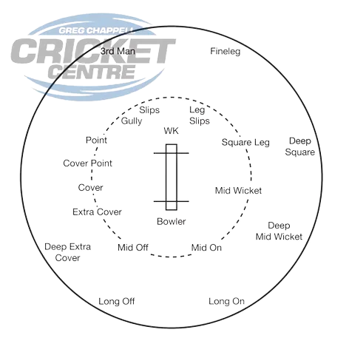
Captain’s Pointers
- Ensure each fielder is in the right spot following the diagram above (can adjust if needed).
- Encouraging each other and helping lift the energy in the field (walking in with the bowler).
- Ensuring bowlers are rotated (give the next bowlers 2-3 overs notice), and subs are rotated, per the tables on this document.

