Brad Crick
Carina Cricket Club Life Member 13
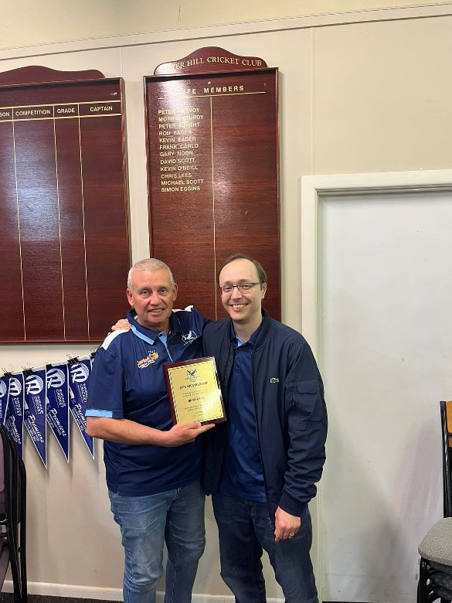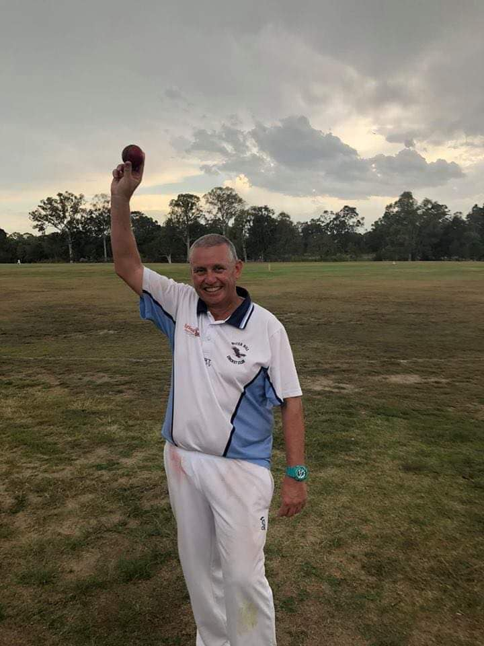

Brad Crick has been a member of our club since winter 2012 and joined the committee in 2016. Since joining, he has played in over 250 games, and taken 500 wickets for the club, Brad has captained what would close to be a record number of seasons mostly in low to mid-grade Saturday competitions. Whilst there have been challenges of trying to remain competitive against strong oppositions, and having to surrender stronger players to higher teams in the club, Brad has always remained positive and created a team environment that players inevitably want to come back to which embodies the true spirit of Carina Cricket Club.
On the committee side of things, Brad has consistently been an active member and is the current Senior Vice-President, taking on many tasks such as frequenting his local supermarket to stock up on drinks and chocolate bars for the canteen to sell each week. He has also assisted with other activities such as clubhouse maintenance, fundraising (including the Bunnings BBQ), and numerous other various miscellaneous tasks. Brad has also served time on the Warehouse committee as the club’s representative.
Brad has given up an incredible amount of his time over the years for the sake of the club and its members, and the club has benefited greatly from what he has had to give and continues to do so.
