Simon Eggins
Carina Cricket Club Life Member 12
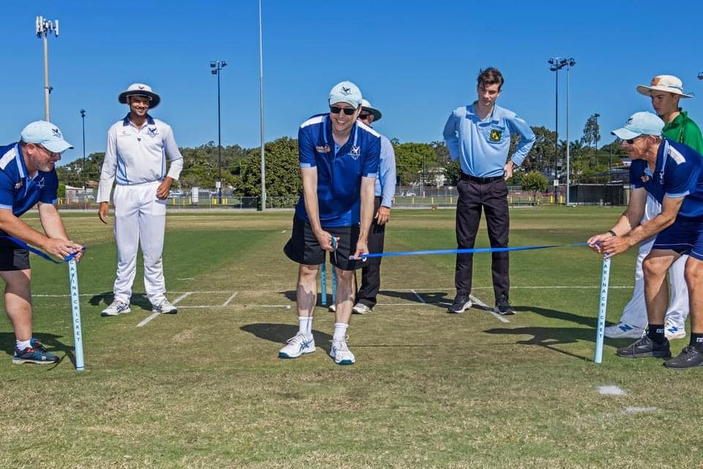
Re-opening of Vince Herbert Oval – 19th May 2024
Simon Eggins has been a member of our club since 2006 and joined the committee in 2007. Since joining, he has played in approximately 350 games which is up there with being one of the most capped members, and scored over 5000 runs for the club, including one century famously brought up with an overhead tennis style shot resulting in all run four. Simon holds the record for being the third highest run scorer at the club (as per records) behind Dave Wilden and Dale Hansen. Simon has also been a team captain winning a premiership for the club and has always remained positive and created a team environment that players inevitably want to come back to which embodies the true spirit of Carina Cricket Club.
On the committee side of things, Simon first joined the committee in 2007 and had two stints in both the Treasurer and Secretary role over a ten year period, as Treasurer, Simon was tasked with keeping up to date and accurate financial records in order to keep the club financial, which he now regards as the most important role in the club, as Secretary Simon looked after the communication and day to running of the club, working through numerous communication platforms that the club utilised during this period, in 2017 as recognition for his dedicated services to the club both on and off the field, Simon was awarded Life Membership of the then named Mater Hill Cricket Club, quite the eventful AGM it was for Simon as he was also elected as Club President on that same night, a role he still holds today and is on track to be the club’s longest serving President.
As President, Simon is a calm, respectful, and reliable leader who always make considered decisions for the club, Simon also treats his fellow committee members with up most respect and provides great support to each of them. Amongst many other successful projects, Simon has been involved with working with the centre to install security cameras at the club which we use to watch the game from now with a FrogBox account which Simon has introduced, he also oversaw our resurfacing and levelling of the outfield and upgrade of the block through 2023, and has helped strengthen the relationship the seniors has with the juniors, showcased by having combined presentation nights and match days.
Being a premiership winning captain, one of the leading run scorers, one of leading number of games played, life member and long-serving President, there is little doubt in our mind that Simon is one of the greatest club members Carina (Mater Hill) has ever had and we are incredibly grateful for the time he has given the club and continues to give. Thank you Simon!
