Pace Bowling Workloads
To prevent long-term injuries for our pace bowlers, the club will be looking to actively manage the workload of all bowlers at the club this season, however, will require the assistance of team coaches.
The coaching director will be keeping a record of roughly how much bowling each bowler is doing so that I can provide advice on workloads where needed.
Match Guidelines to follow for bowlers:
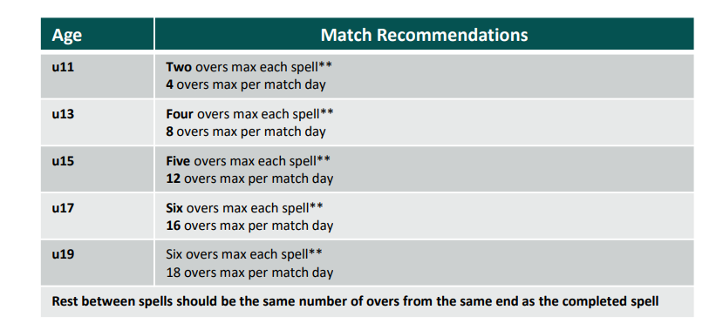
Training Recommendations:
U15 – No more than three bowling sessions (two for injury prone players). One day rest between each session. If have to do back-to-back days, then take next two days off. 90-100 balls in a week.
U16-U17 – No more than three bowling sessions. One day rest between each session. If must do back-to-back days, then take next two days off. 110-120 balls in a week.
