Captaincy & Field Placements
Captain guidelines
U9s-U12s – All team members have a go at being captain or vice-captain.
U13s and U14s - 2-3 captains, doing blocks of 3-4 weeks each, this is a good balance of ensuring multiple players learn the skills of captaincy but still giving them multiple weeks in the role thus allowing them to learn and grow as a leader.
U15s onwards – Set captain and vice-captain.
Key Attributes for a Captain
Respect – Treats umpires, coaches, teammates, and opposition with respect at all times.
Vocal – Is active in encouraging teammates on the field and whilst batting.
Emotionally Level – Doesn’t get too ahead of oneself when things go well nor too down on oneself when things don’t go well.
Tactical Understanding – Able to work with bowlers to create plans and set fields for those plans.
Adaptable – Able to adapt tactically to an evolving game situation and re-adjust plans.
*Last two points are more for U13+ players. Field Placements
General guidelines when setting fields
- Know your bowling, what type of bowler are you (leg spin, outswing, medium pace etc.).
- Understand the situation of the game. - What bowl are you trying to bowl? How are you trying to restrict the batters scoring / get the batter out?
- What shots are the batter most likely to play?

In swing bowler
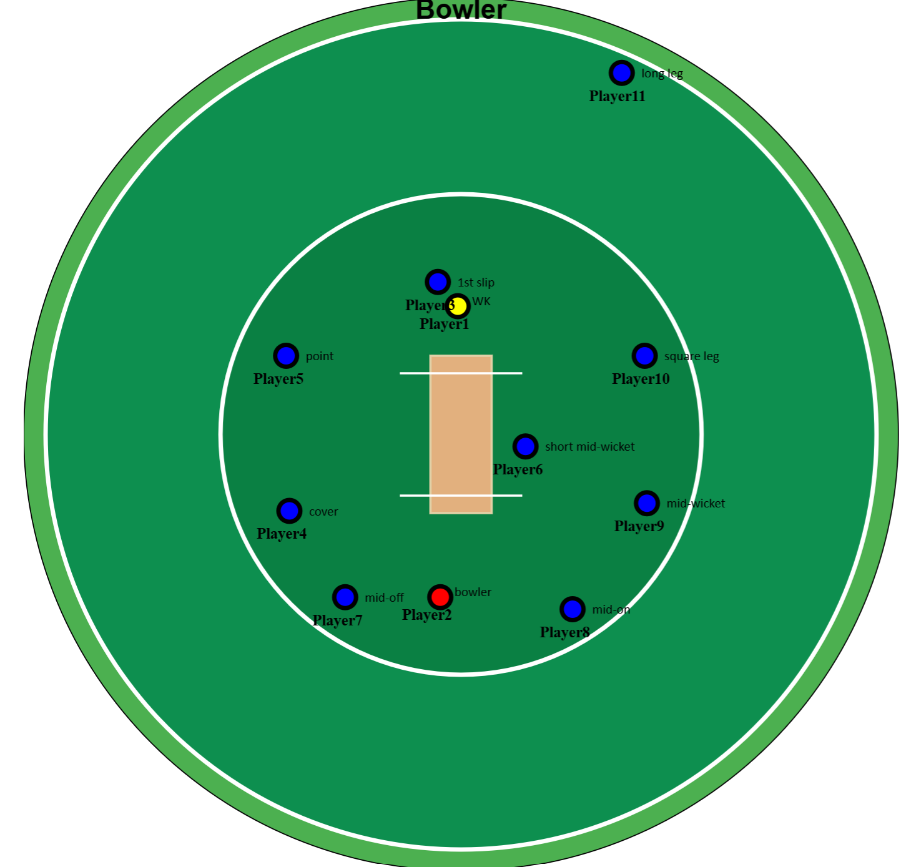
Out Swing Bowler
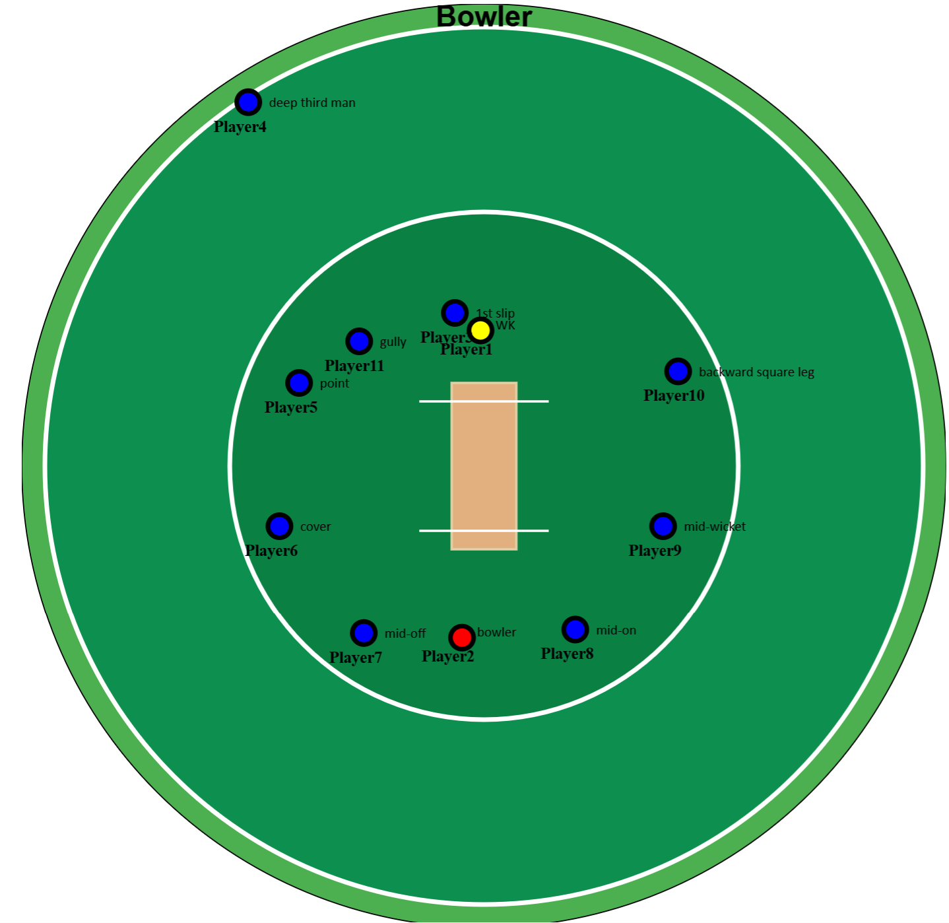

Spin Bowlers
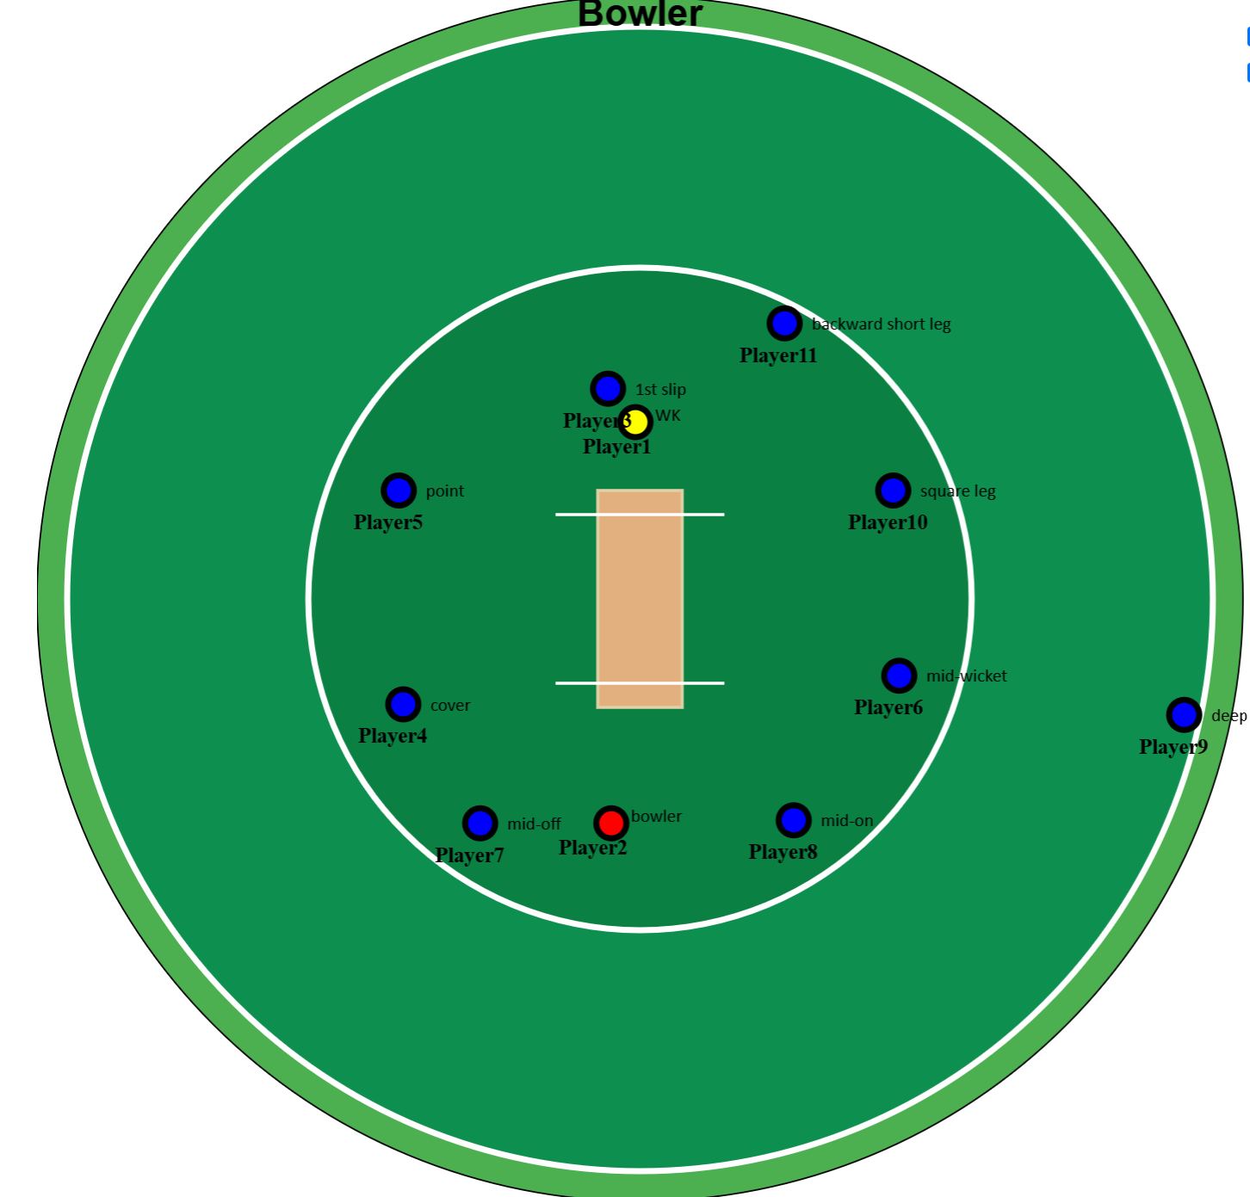
Fast Medium Bowlers
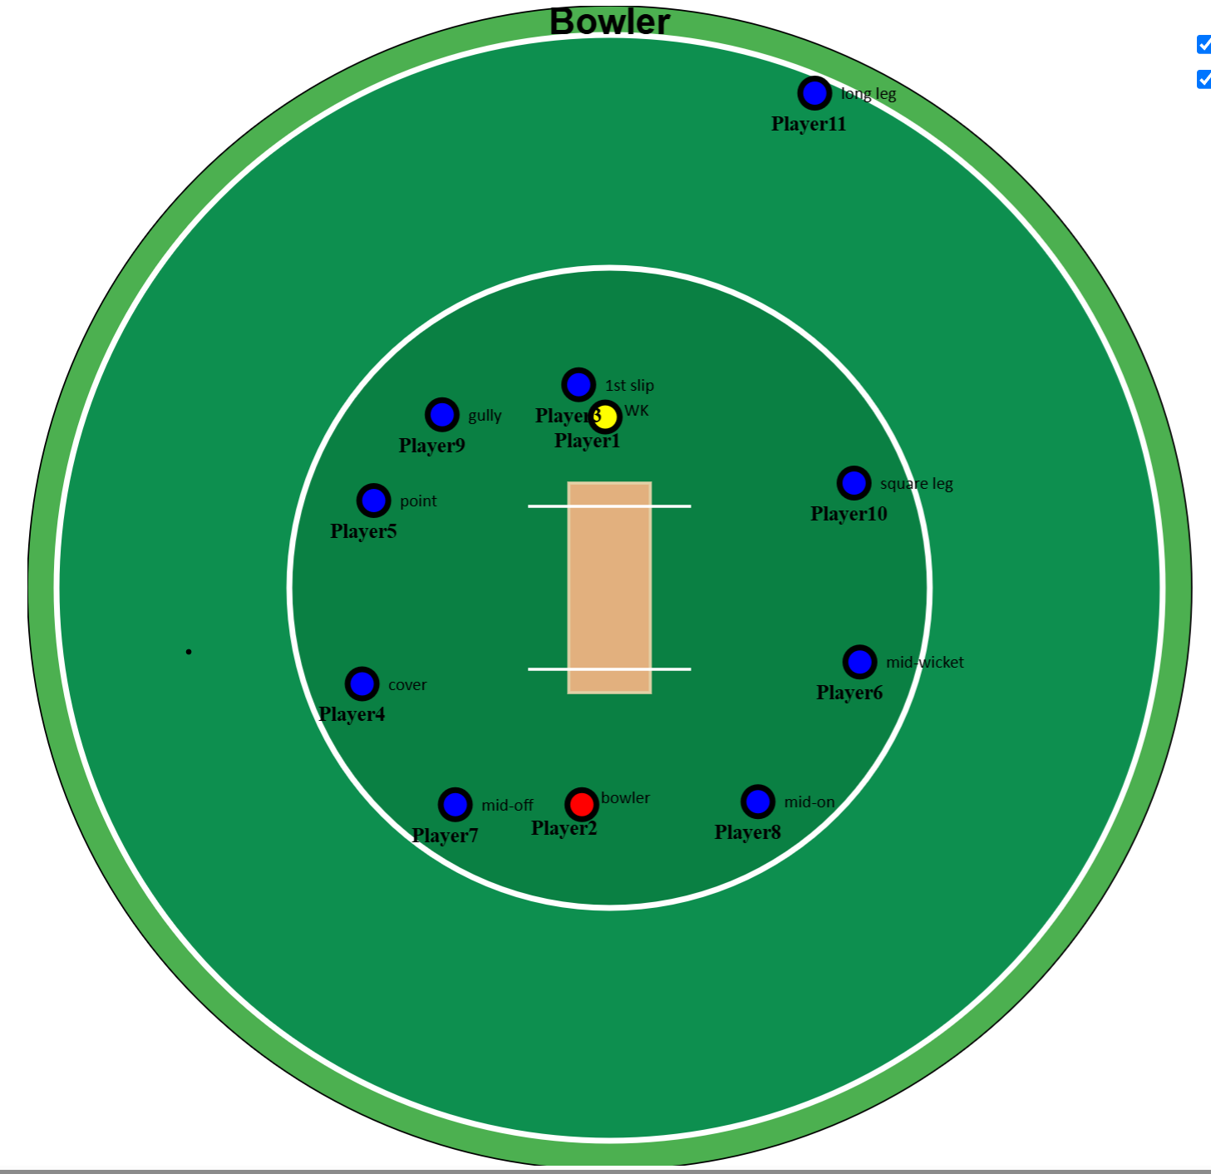

Inexperienced bowler
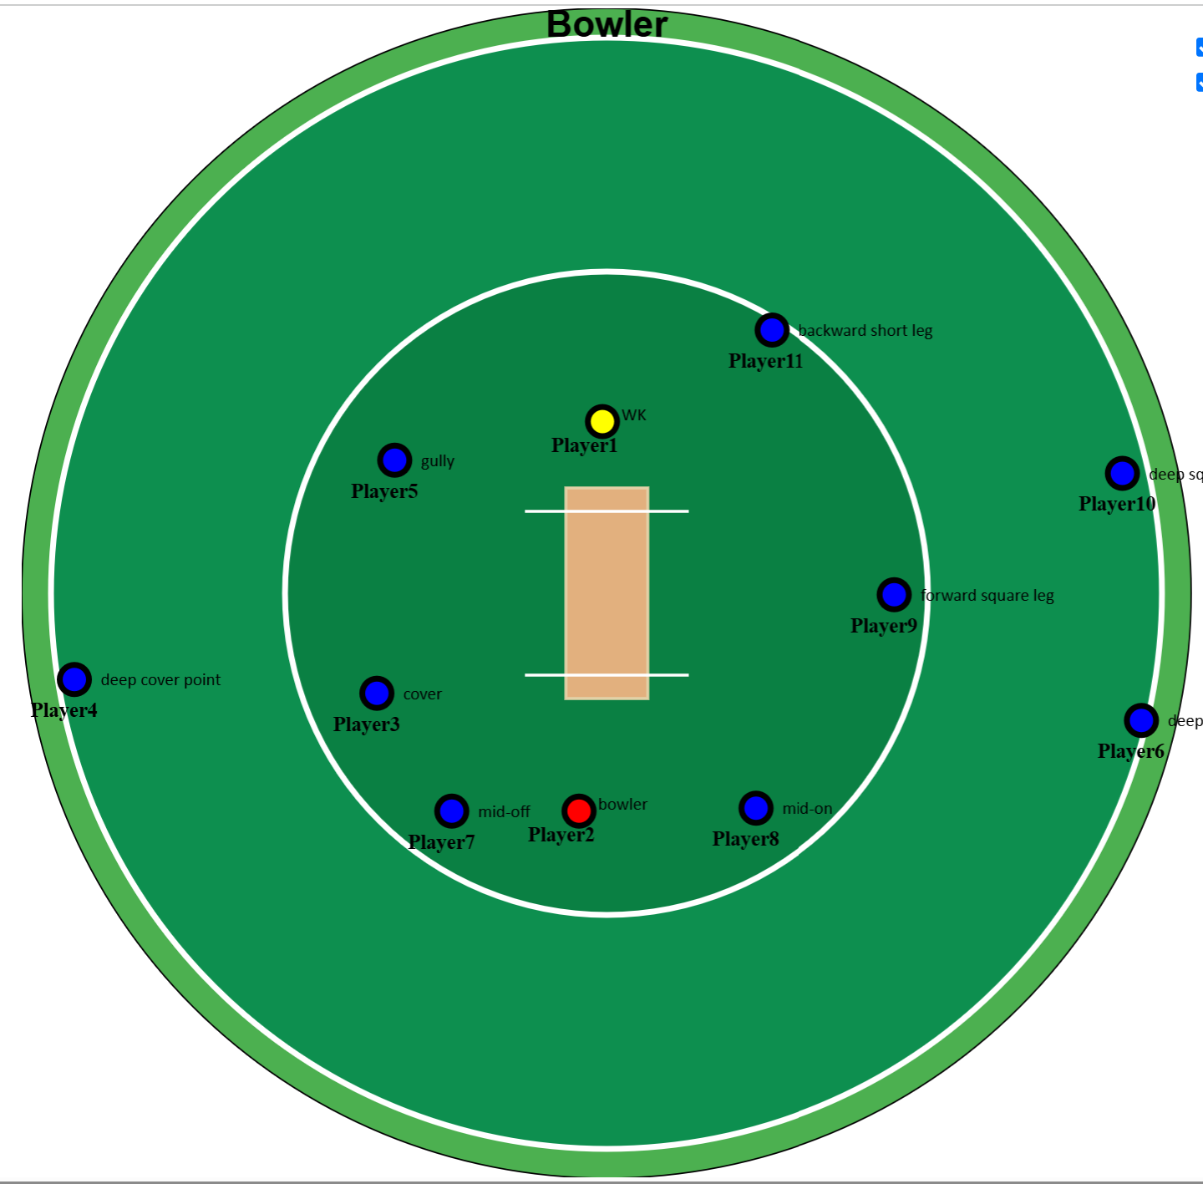

Defensive Field (Bowling Outside Off)
