Carina Cricket Club Team Manager Tasks
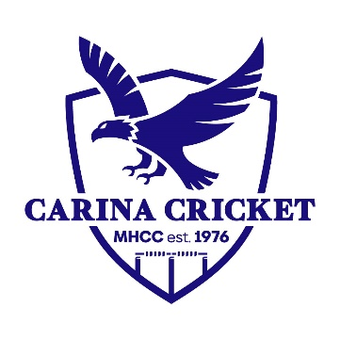
Before the season:
- Contact team to advise dates for training and games.
- Set expectations around parent help (scoring and umpiring).
- Send link for uniform purchase.
- Check WhatsApp and emails for any updates from club officials.
Weekly Tasks:
- Communicate time and location of the game, check PlayHQ website for this and not PlayCricket app or PDF file of draw as there can be changes. Include venue information such as parking, shade, toilets etc.
- Organise scorers and umpires for each week. A roster at the start of the season to send out and then refer to each week can work well too.
- Select the team list on PlayHQ the day before the match at the latest.
- If need fill in players, use the junior fill in policy as a guide to assist.
Game Day:
- Assist the coach where needed.
- Ensure umpires and scorers are in place and assist them where needed.
Post Game:
- Enter the scores on PlayHQ.
General Tasks:
- Sending out reminders on the club’s behalf to your team.
- Collecting RSVPs for end of season breakup.
- Take team photo and send it to the club (Millan).

