Ron Eager
Carina Cricket Club Life Member 04
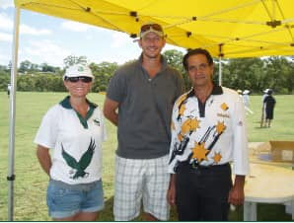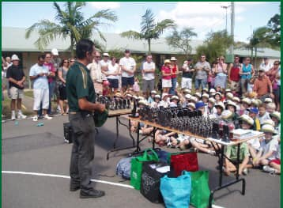

Ron Eager was an incredible volunteer at Carina and in our region, whose passion and dedication for the community stood above all, Ron saw clubs as being for its members whilst associations like EDJCA & BEARS were about the clubs within them.
Ron was that rare breed of being an amazing organiser, plus a visionary. He organised training and matches for literally thousands of junior cricketers, season after season after season. He became a major player in Mater Hill / Carina Cricket Club when he saw that many of “his” BEARS charges lacked a pathway to senior cricket. So, Ron engaged with Mater Hill to combine Carina juniors with Mater Hill Seniors to become one club. He encouraged / recruited senior cricketers to become coaches and managers of junior sides whilst advising which juniors could (and couldn’t yet) step up to fill in for senior sides when they were short, this helped build a strong link between the two arms of the club. Ron was Carina’s longest serving Junior President, holding the esteemed position for over 20 years (many years not having a child at the club) and formalised this role as part of the club’s main committee to ensure the interests of the juniors were represented club wide. He has built the Carina Juniors to what they are today, and actioned the name change from Mater Hill to Carina for the juniors in the mid-2000s. He was around before the days of online registrations and would often hold sign on days at the club, spending hours on end ensuring new members of the club felt welcome and answering all their questions. However, despite his many achievements, Ron was known as quite the unassuming figure around the club, happy to put the work in whilst the members took centre stage on the field with Ron watching on.
On top of this, Ron was always a regular at working bees at the Clem Jones Centre working to ensure we had a active community with good standard facilities, and held executive positions with both EDJCA & BEARS. Ron holds the highest recognition of being a life member of Carina, EDJCA and BEARS as well as being a life member of two racing organisations.
Grounded on the values of participation, inclusivity, and enjoyment, the Ron Eager Cup was set up for U11 juniors to have their first carnival cricket experience before rep cricket selections the following year. This carnival is run and organised exclusively by volunteers under EDJCA and the clubs within.
Up until 2022, Ron would be at the carnival every year on Friday afternoon to present the winning team the Ron Eager Cup. Sadly, just days before the Ron Eager Cup of 2023, Ron passed away but his legacy will live on as an inspiration to others. All clubs at the carnival in 2023 wore black armbands and observed a moment’s silence in his memory.
We will forever be grateful for his hard work building the region and club to what it is today. We would not be where we are today without Ron’s dedicated voluntary efforts.

