 | Bowling | Subs |  | Bowling | Subs
1 |  |  | 14
2 |  |  | 15
3 |  |  | 16
4 |  |  | 17
5 |  |  | 18
6 |  |  | 19
7 |  |  | 20
8 |  |  | 21
9 |  |  | 22
10 |  |  | 23
11 |  |  | 24
12 |  |  | 25
13
Game Day Running Sheet
Date:
Location:

Batting Order | Minimum / Maximum Balls | Fielding overs 1-13 | Fielding overs 14-25 | Overs bowling
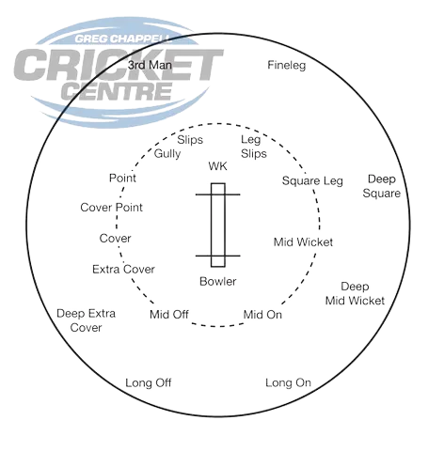
Coach / Captain’s Pointers
- Ensure each fielder is in the right spot following the diagram above (can adjust if needed).
- Encouraging each other and helping lift the energy in the field (walking in with the bowler).
- Ensuring bowlers are rotated (give the next bowlers 2-3 overs notice), and subs are rotated, per the tables on this document.
- Next bowler simply switches fielding positions with previous bowler.
- U12s and above, next bowler goes to fine leg at the end they are bowling at.

