

Carina Cricket Club Game Day Handbook
By Millan Agarwal
Coaching.director@carinacricketclub.com.au
0404692504

Prior to Game Day
Complete run sheet with use of template and reference to rotation policy.
Circulate run sheet.
Print 4-5 copies of run sheet.
Familiarise yourself with the rules.
On Game Day
- Arrive 15 minutes before the team arrives to set up. If home team the following will be required to be set up; one set of stumps, boundary markers (35m for U9-U10, 45m for U11-U12, 55m for divisions 5 and below, 65m for divisions 1-4), fielding discs and batting tees if applicable, warm up. If away team, the following will be required; set of stumps and warm up.
Boundary markers are done by starting in the middle of the pitch and walking out the boundary length from the pitch and then doing a circle of cones all the way around. It does not need to be exactly the set distance as it will be the same for both teams. In a two day game, simply ensure the same person marks the boundary both weeks to ensure consistency. However, teams are welcome to bring a tape measure if they so wish to.
- Upon players arriving, start with a simple warm up for ten minutes. Followed by team discussion.
Teams U12s and above – Dynamic warmup, warm up game, team chat about expectations and roles for the day.
Teams U11s and below – Pairs catching and throwing, team chat about expectations and roles for the day.
Discussion framework:
- Key expectations/focuses in general, then batting, bowling and fielding.
- Batting and bowling orders.
- KPIs (Key Performance Indicators) – small goals to achieve as a team such as less than 20 extras, get two run outs etc.

- If time permits, fielding drills warm up 10-15. Usually, only teams who meet 45 minutes before the match will have time for this.

- Coin toss. Usually done 20 minutes prior to starting. Usually recommended teams bowl first unless a two-day BEARS divisional match as it avoids having to field in the hottest part of the day. IMPORTANT – this is the opportunity to talk to the opposition coaches about potential matters of contention wides, no balls, key rules, drinks breaks, timings, asking the opposition for a sub fielder if we need one etc.
- After the toss and before the game starting – skills specific warm up. If batting, top four pad up and the rest of the players give throw downs, use parents to assist if needed. If bowling, half the team practises bowling beside the pitch with the wicketkeeper / parent helper, other half practice fielding with the coach, swap after 5-7 minutes.

- Five minutes prior starting – players go off the field to top up sunscreen, have a drink etc. , final team chat with key reminders before game starting.
Note – it is the team manager’s responsibility to ensure all volunteers are in place for their roles whilst the coach focuses on the players.
- During the game, see below.
When batting: U9-U12s – help the batters with any tips they need, coaching on the field allowed so long as it doesn’t slow the game down. Coach allowed on the field at U9-U11s. Less so in U12s as coach is not allowed in the filed but coaches are still encouraged to help batters. BEARS Divisional – if on the field umpiring, coaches are allowed to give some tips, otherwise, coaches are best fit for sitting with the other players and helping players read and understand the game and talking to the incoming batters about what’s needed of them. ALWAYS ensure next two batters are fully padded up, this role is delegated to a parent in U9-U11s.
When bowling & fielding: U9-U12s – help the batters with any tips they need, coaching on the field allowed so long as it doesn’t slow the game down. Coach allowed on the field at U9-U11s. Less so in U12s as coach is not allowed in the filed but coaches are still encouraged to help. Coaches are responsible for coordinating subs on and off the field if applicable. BEARS Divisional – if on the field umpiring, coaches are allowed to give some tips, otherwise, coaches are best fit for sitting with sub players or sit off to the side and delivering messages where needed. Coaches are responsible for coordinating subs on and off the field if applicable.

- Drinks breaks – Communicate what we are doing well and what we can do better for the next phase of play, as well as what our goal should be.

- Post game – Discussion with the players. What did we do well? What can we improve on? What did we learn? Award Player of the Day. Note every player must have won the award once before someone can win it twice.

After Game Day
- Send brief match report to team and WhatsApp coaches and managers group. OPTIONAL.
- Consider strengths and weaknesses from previous game day when planning next training session.

Warm Up Games

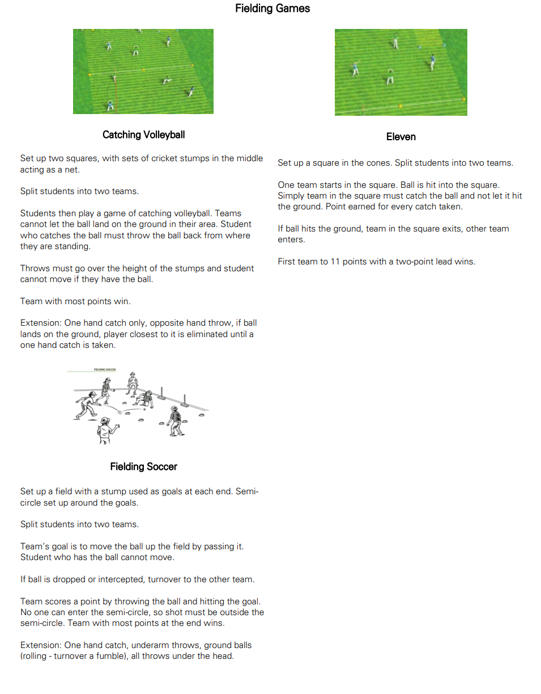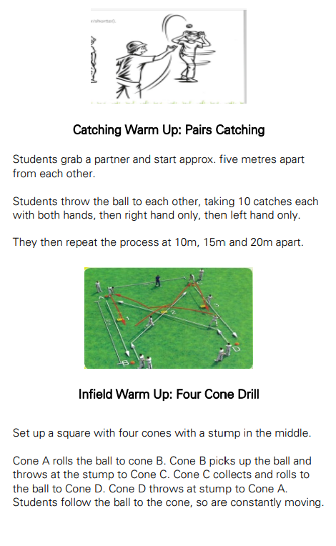

Key Points to Reinforce During Matches

U9-U10s – Batting; moving to the ball, full swing of the bat, hitting in different directions, running between the wickets. Bowling; straight lines, building speed in to the crease, front arm up, head up, follow through. Fielding; staying alert, backing up, knowing when to attack or defend, attempting all catches.
U11-U12s - Batting; moving to the ball, full swing of the bat, hitting in different directions, decision making (forward or back, attack or defend), running between the wickets. Bowling; straight lines, building speed into the crease, front arm up, head up, follow through, bowling to the situation of the game. Fielding; staying alert, backing up, knowing when to attack or defend, attempting all catches.
U13s+ - Batting; moving to the ball, full swing of the bat, hitting in different directions, decision making (forward or back, attack or defend), adapting to conditions, plaing to the situation of the game, running between the wickets. Bowling; straight lines, building speed into the crease, front arm up, head up, follow through, bowling to the situation of the game. Fielding; staying alert, backing up, knowing when to attack or defend, attempting all catches, knowing the situation of the game.

