Warehouse U15 Competition Rules Summary

General Rules
- Minimum Seven (7) players in each team to play the game.

- Helmets mandatory for all batters and keepers up to the stumps. Keepers standing back don’t have to wear a helmet per Warehouse rules, however, we as Carina Cricket Club would recommend keepers always wear helmets, aligning to the policies set by our summer competition.

- ‘MINIMUM FIELDING DISTANCES - No fielder is allowed closer than seven metres from the popping crease of the batsman on strike, and if they are between 7-10 metres they must wear a helmet. The exception to this is behind square on the off side.
U15 Competition Rules (Source; Warehouse Cricket Association 2025 Winter Saturdays Handbook)
Two Day Games (also applies to the one-day games unless advised otherwise in the ‘One Day Games’ section)
GAME SET UP
- Boundary as per provided.
- Full pitch.

PLAYING TIMES.
- Commence 11.30 a.m. Finish 4.20 p.m.
- Time Lost: A penalty of 0.25 points for each four (4) minutes lost will apply to teams who are not ready to commence at the appointed time.
- Minimum 70 overs need to be bowled each day; play will continue beyond 4:20pm to achieve this.
TEA BREAKS AND DRINKS
- A tea-break of 20 minutes will normally be taken at 2.00 p.m. during a two (2) day game unless an innings is terminated within 30 minutes of the scheduled time, in which case, tea will be taken immediately. Tea will be at 1:45pm if playing at KP 1,3,5,7,9 and 11.

- If play does not commence before 12.45 p.m., no tea break will be taken and there will only be one session of play.

- If at the agreed time for the tea interval, nine (9) wickets are down, play shall continue for a period not exceeding 30 minutes or until the innings is concluded.

- One drink break of two minutes shall be taken each session (the play before tea is one session and the play after tea is the second session). Such a drink break shall be taken between 60 and 90 minutes from the commencement of play in that session.

LENGTH OF FIRST INNINGS
- There is no limit to a length of an innings, a batting innings in one of two ways, a declaration is made OR ten wickets are lost.

- Interruptions: If play does not commence on the first scheduled day of a match, then the second scheduled day will be conducted as a One-Day game. 35 overs per innings.

- When an innings ends and a new innings is to commence before the scheduled fi nishing time, the minimum number of overs remaining to be bowled shall be determined by dividing the time remaining for play by 4 minutes. A 10 minute break for change of innings will be allowed.

- The second innings, provided time permits, shall be played to an outright result. No limit shall apply to the total number of overs, but normal individual bowling restrictions apply.

MINIMUM OVERS TO BE BOWLED IN A DAY

- Should the minimum number of overs not be bowled, a penalty of 0.25 premiership points shall be applied to each of those overs not commenced, at the scheduled finishing time; excepting any overs which are not commenced due to; extenuating circumstances, bad light, ground conditions and/or weather, or the batting team is bowled out.

- If, at the scheduled finishing time, the minimum number of overs has not been bowled, then play shall continue if playing conditions permit, until the minimum number of overs has been completed.

- On the first day, when a wicket falls during the last of the required overs and within three (3) minutes of the scheduled finishing time, STUMPS WILL BE DRAWN IMMEDIATELY.

- On the first day, if at the scheduled finishing time, a suspension of play occurs as a result of playing conditions and/or the players are already off the field of play, STUMPS WILL BE DRAWN.

- When an innings is completed after the scheduled finishing time on the first day, STUMPS WILL BE DRAWN.

- If the first day is cancelled, then the second day will be a 35 over one day game.

BALLS PER OVER
- Maximum ten balls or minimum six legal balls to constitute an over.

FOLLOW ON
- Lead of 75 runs needed as a minimum to enforce the follow on.

NO BALLS & WIDES
No balls for the following reasons;
- Underarm bowling.

- Ball bounces above shoulder height when the batter is standing up right at the crease.

- Ball bounces more than once, stops or rolls, before batters’ crease.

- Ball bounces off the pitch.

- Ball passes above waist height on the full, when the batter is standing up right at the crease.

- If no badged umpire present, square leg can help call the height for no balls, despite what the rules say, I’d suggest making an agreement with the opposition umpire in this case. The rules are written for conventional Warehouse situations where there is a badged umpire present.

- Any ball out of the batsman’s reach is regarded a wide, common sense needs to prevail here and consistency is key.

NUMBERS IN A TEAM
- A team may bat & bowl 12 players with an innings being concluded on fall of 10th wicket. In teams that have 13 players, we can seek approval to bat and bowl 13 players, participation if key.

BOWLING RESTRICTIONS

- Twelve (12) overs maximum per bowler in the first innings and in a day. Five overs in a spell maximum. Must wait 60 minutes of actual time minimum between end of fifth over and start of sixth over, irrespective of whether the first four overs are bowled in a spell or not. Spinners may bowl their twelve (12) overs consecutively.
BATTING RESTRICTIONS
- Minimum 40 balls for retirements.

- No maximum retirement.

- A not out batsman can resume his/her innings once all other players have retired or are all out in the order in which they were retired.

- Wides and no-balls do not constitute a ball faced for the purpose of counting minimum balls faced per batsman.

- No batter can be retired without facing a minimum of 40 balls.

GAME RESULT
- When the innings of the team batting first is concluded, the runs scored plus 1 will be the Target Score.

- A first innings win will apply to the team which scores the highest runs after the completion of the first innings of each team. When both innings aren’t complete, the result will be a draw.

- 0.01 competition points are awarded for every run scored.

- 0.25 competition points for every wicket taken.

TABLE SUMMARY OF COMPETITION POINTS
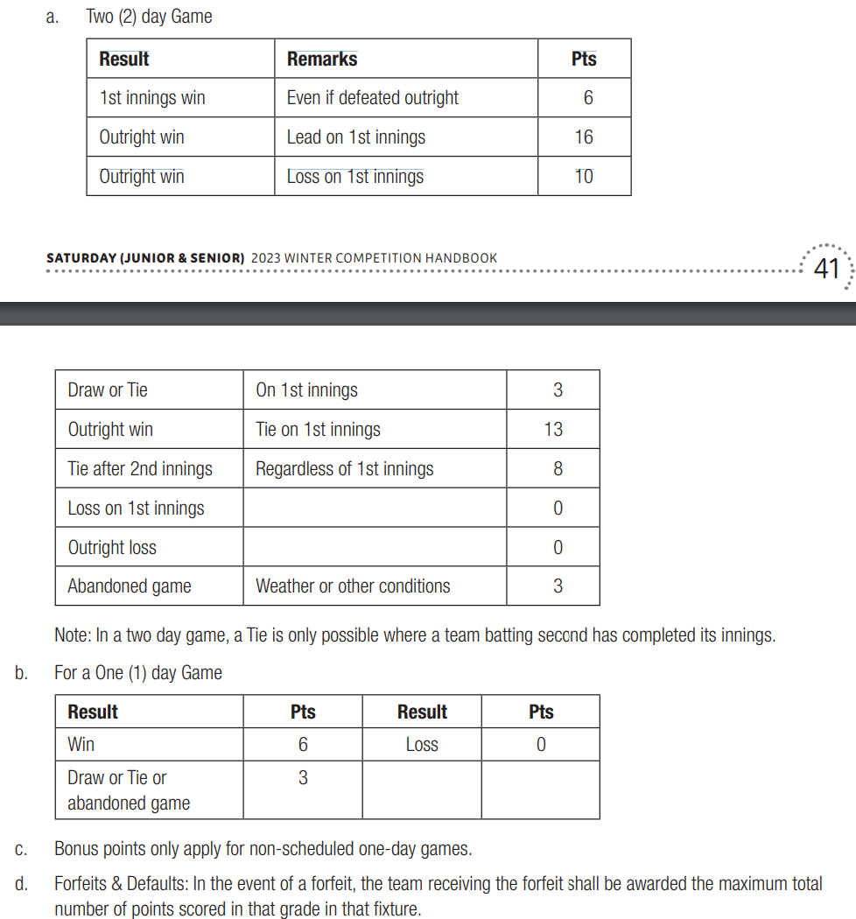

FIELDING RESTRICTIONS

- No more than two fielders behind square on the leg side.

One Day Games

PLAYING TIMES.
- Commence 11.00 a.m. Finish 4.40 p.m.

- Innings Break 20 minutes.

- Basis of the game will be: 40 Overs per innings If the innings of the side batting first has not been completed, there shall be a compulsory closure at: 1.40pm. The side batting second, if not dismissed, shall be entitled to bat only for the same number of overs as has been bowled to the side batting first. For unscheduled one day games (day two a of a two day game, where day one is washed out), it is 35 overs per team, 11:30-4:30pm, with a first innings cut off at 1:50pm and change of innings of 20 minutes. 7 overs per bowler.

- Wet Weather - for any match in which the start is delayed by weather or the innings of the team batting first is otherwise interrupted by weather, the compulsory closure time shall be adjusted on a pro rata basis to the available playing time, ie, the interval between innings shall occur midway in the time available for play. The target number of overs shall be reduced on the basis of one over for each 4 minutes or part thereof, lost from the time available for the first innings.

- If the innings of the side batting first has been completed other than by compulsory closure, then the side batting second, if not dismissed, shall be entitled to bat for the maximum number of overs, if required. If the last wicket falls at, or after the time for the interval, but during an over commenced before this time, the team batting second shall be entitled to receive the same number of overs as they have delivered; fractions of overs count as full overs for this purpose.

- There is NO second innings cut off time, the game finished when the required overs are bowled.

- Each team must bat at least 15 overs for a result to be achieved.

- 2-minute drinks break after 20 overs

BOWLING RESTRICTIONS

- Eight overs maximum per bowler in an innings. Five overs in a spell maximum. Must wait 30 minutes of actual time minimum between end of fifth over and start of sixth over, irrespective of whether the first four overs are bowled in a spell or not. Spinners may bowl their eight overs consecutively.

GAME RESULT
- A win/loss result is affected when either the target score is reached, or the team batting second is all out.

- In matches where a result can, be achieved and in which the team batting second has not had the opportunity to bat for the target number of overs and has neither been dismissed, nor passed its opponent’s score, the result shall be decided on the average run rate throughout each innings. This is only after each team has batted 15 overs.

E.g., Using a 35 over innings: - 2nd innings reduced to 20 overs Note: eg: Where fi rst team bats through innings. Team batting first = 175 runs in 35 overs = 5.00 Team batting second = 101 runs in 20 overs = 5.05

E.g., Using a 35 over innings: (Game washed out after 30 overs in 2nd innings) Where team does not bat through innings. Team batting first = 105 runs (all out) in 30 overs = 3.00 Team batting 2nd = 106 runs in 30 overs = 3.53.

Where there is no badged umpire in attendance, each captain should sign the opposition’s scorebook at the end of the game to confirm the result.

NO BALLS
- Free hits are in play for no balls.

WIDES
- Maximum ten (10) balls per over. Minimum of six legal deliveries.

- LEG-SIDE: A ball which pitches outside the line of the leg-side danger area indicator (a line drawn 30 cm from the middle stump) and continues to move down the legside, as a guide, should be called a wide.

OFF-SIDE: A ball which passes the batsman outside the line of the off-side maker (a line drawn 75 cm from the off Stump), as a guide, should be called a wide.

- The above provisions do not apply if the striker makes contact with the ball.

- Key is for umpires to call wides when the batter can’t reach the ball and be consistent, that is the easiest to keep it fair and the game moving.

FIELDING RESTRICTIONS
- No more than five fielders on the leg side.
- No more than two fielders behind square on the leg side.

BATTING RESTRICTIONS
- Minimum 25 balls for retirements.

- No maximum for retirements.

- A not out batsman can resume his/her innings once all other players have retired or are all out in the order in which they were retired.

- Wides and no-balls do not constitute a ball faced for the purpose of counting minimum balls faced per batsman.

- No batter can be retired without facing a minimum of 25 balls.

