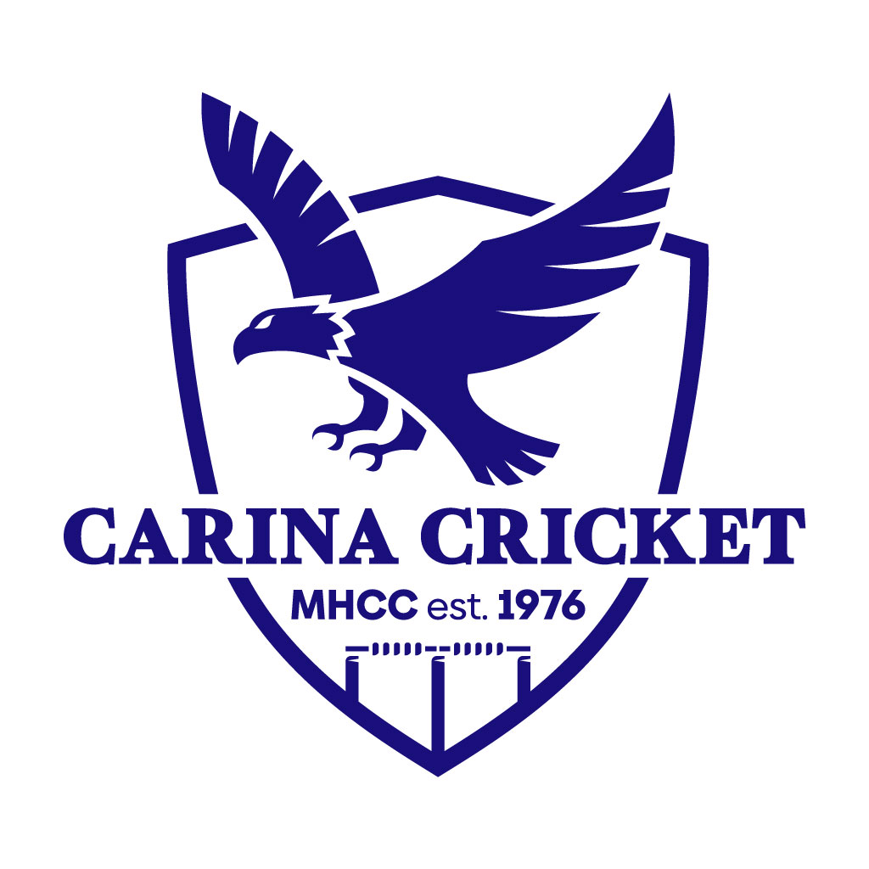

Carina Cricket Club U11-U12s TRAINING GUIDE
By Millan Agarwal
Coaching.director@carinacricketclub.com.au
0404692504

Contents

- Club philosophy of U11-U12s.
- Key coaching and team management tips.
- Training outline.
- Ideas for net sessions.
- Bowling coaching (most important).
- Batting coaching.
- Fielding coaching.
- Other training ideas.

Club Philosophy

Enjoyment - players enjoying themselves and having fun. This is still very early in their cricket careers, so we want them to fall in love with the game.
Participation - equal opportunities for all players to learn and improve at the game.
Improvement – Players are better players at the end of the season than they are at the start of the season.
Connection - connecting with the player on a greater level than cricket and building that community atmosphere amongst the team and club. Have a social gathering as a team.

Coaching and Team Management Tips

- Make it fun – kids learn skills much easier if they are enjoying themselves
- Make activities competitive
- Ensure every activity has a clear purpose
- Keep the players involved and engaged – avoid doing activities where kids are standing around
- Plan our sessions
- Keep it simple
Training Sessions
Session length
90 minutes.
Session Structure
5 minutes - warm up
40 minutes – field activities
45 minutes – nets activities
Warm Up (Refer to Warmups & Fielding Guide)
Dynamic warm up and warm up game.
Field activities (Refer to Warmups & Fielding Guide)
One fielding game – fun + competitive
One fielding drill – technique + purpose
One game sense / fitness drill – everyone involved + match simulation
Net Sessions (Refer to Batting & Bowling Skills and Drills Document)
Week 1 – Live net session where bowlers bowl to batters. Ensure the session has a clear purpose for bowlers and batters.
Week 2 – Live net session where bowlers bowl to batters. Ensure the session has a clear purpose for bowlers and batters.
Week 3 – Batting and bowling skills drills. Involve parents to help.
*Repeat three week cycle for as many times as required
End of Training
Debrief the session – What did we focus on? What did we learn? What do we need remember for Saturday? Go through run sheet for Saturday?

Live Net Sessions
How can we add purpose to our live net sessions?
- Free hit game. Set up cones either side of the stumps and if the bowlers bowl outside the cones it becomes a free hit. Encourages bowlers to bowl straighter and batters to not chase ones and practise their power hitting when they get a free hit.

- Cones game. Set up cones / attach towels on the net that represent the angle of fielders. Batters aim to hit the gaps and call loud to run or not, running between the wickets can be practised here too (turning, running hard, calling and decision making). Bowlers practise bowling consistently to contain the batters from scoring. Perhaps a scoring system can be used (bowlers get points for dot balls and wickets) to see who the winner is and therefore make it a contest between bat and ball.

- Ball along the ground game. Set up a ‘box’ around the batter, the batter must have the ball bounce at least once (or twice to really challenge the players) in the box after they hit it. Discretion can be used for back foot shots (downward trajectory). Bowlers aim to bowl good balls consistently and force batters to take risks which may them hit the ball without it bouncing in the box. A scoring system can be used where batters get points for bouncing it in the box, and bowlers get points when they don’t.

- Out net. As soon as the batters get bowled, caught behind, lbw or hit a catchable delivery, they are out, and their session is done. Makes batters value their wicket and bowlers love nothing more than getting batsman out! If you really want to challenge the players, you can include running between the wickets, if they turn blind, don’t call loud, or wrong person calls, batters can also be given out, a great way to help remove these habits.

- Scenarios. Coach nominates a match scenario, and the players play according to it, can be start of an innings, middle of innings, saving the game or a run chase. Encourage bowlers to set a field to get them thinking tactically. Can make this competitive, to help increase competition between batters and bowlers.

- Decision making. Batters play according to the ball bowled at them, could use cones to help batters identify which balls to attack and defend. Bowlers get rewards (points) when batters give a chance for a wicket or get out. Scoring could be something like; 1 point for defensive shot, 3 points for attacking shot, bowlers get five points for drawing a chance, and ten points for a wicket. Batters are required to make decisions on which balls to attack and which to defend, wrong decisions could lead to the bowlers’ getting points.

- Calling the length (probably only against spinners and medium pacers). Batters call the length off the ball as it’s coming at them (full, good, short). Batters get points for making the right calls, bowlers get points for wrong calls. Batters work on decision making and being decisive on their picking of length. Bowlers aim to bowl that in between good and full length to challenge the batters’ decisions and the bowlers’ control.

- Swing balls. Bowlers bowl with the swing balls and learn how to control it, batters practise playing against the swinging ball.

- Target practise. Put some targets on the pitch for bowlers to aim at and offer prizes as an incentive for them to aim at them. Batters have to be watchful around the target, but attack when they miss the target, can set up a scoring system to reinforce this.

- Three batters per net. Two batters and one reserve batter. When one of the batters gets out, makes a running between the wickets error, or any other error the coach decides to incorporate as part of the rules, they must swap and become the reserve batter. Encourages batters to make smart decisions as consequences are involved, bowlers bowl consistently and try and dismiss batters.

Skills to Teach
Batting Include Videos
- Recap skills taught in U9-U10s. Points 2-7.

- Teaching players how to hold the bat and what stance is required. https://youtube.com/shorts/GNHXQukTMjg?si=bsA_2pZP_7rvbY1p

- Getting players comfortable hitting a ball with a cricket bat, key coaching points are watching the ball, being stable (one step), and full bat swing, therefore, a lighter bat is best for beginners. Does not need to be straight bat at this stage. https://youtube.com/shorts/W4v0KemKxy4?si=ESCY5bOPOjcPWWPi

- Teaching batters to hit in different directions, footwork, head position, and different swing planes (straight bat and cross bat), straight, offside and leg side. Introduce the concept of straight bat. All front foot at this stage. https://youtube.com/shorts/vxy50h_YJuI?si=jb7VioNy3ZJ_Igx1

- Teaching players to hit along the ground and defend the good balls (introduces decision making). All front foot at this stage. https://youtube.com/shorts/NtNUNP2GCCI?si=hBrUKCBGR_Gn7D3P

- Running between the wickets – Yes, no, wait. How to turn correctly? Knowing when to run, sliding the bat, correct running technique. Backing up at the non-strikers end.
Backing up RBW - https://youtube.com/shorts/zQmpcrwg9t4?si=d9kWq32ifA1ZLWZE
Turning RBW - https://youtube.com/shorts/ok-M1J-LW2s?si=BQSw3yTJFwe7JqMY

- Teach players to use back foot. Pull shot, back foot drive, cut shot.
Pull shot basics - https://youtube.com/shorts/o--VklI-IkY?si=pT-gw8WEYhQyJDrw
Back foot drive - https://youtube.com/shorts/0v61ol1Ghj8?si=T38J_u2WYPZUIVWu
Cut shot - https://youtube.com/shorts/0IiLIMzyudI?si=xT208p4EaqINEZiq

- Getting players used to batting against the hard ball.

- Batting against spin bowling. Include advancing and sweeping.

Batting again spin - https://youtube.com/shorts/uOdKK0_yTpA?si=DVfz4UU2V1Hp30nN
Advancing down - https://youtu.be/1G2g2dt2LvM
Sweep Shots - https://youtu.be/cF0RsFlnifo

- Power hitting.

Power hitting explanation - https://youtu.be/1G2g2dt2LvM
Power hitting drill - https://youtube.com/shorts/d9Bp99O3pB8?si=n3a0aDQnOxdcEnxr

Bowling Include Videos
- Recap skills taught in U9-U10s. Points 2-10.
- Bowling with a straight arm and being able to make the distance. https://youtube.com/shorts/oO0ussmjNzI?si=ri8olc9iyCHsXNIJ
- Ball grip. https://youtube.com/shorts/Ev1mcfGARUo?si=fBpQ4eM0gF0jtNYz
- Approach to the crease. https://youtube.com/shorts/eywallua83o?si=-zEhKTMcmyyZLdwl
- Alignment. https://youtube.com/shorts/cTk15yVeMjY?si=64ISrSLqxgxA_VWO
- Gather. https://youtube.com/shorts/u9EQjimYg5A?si=5H8hJV1Ofr1y7wAG
- Safe action. https://youtube.com/shorts/hfGSp4CyG4E?si=m-O0InaFhVKODyOM
- Front arm. https://youtube.com/shorts/bqkyZUbggKY?si=N_OdrJuNKINV9TY9
- Head position. https://youtube.com/shorts/V-dhU6NF-ZM?si=SYj9au2RnmxJGba4
- Follow through. https://youtube.com/shorts/EtD3t_0qfjQ?si=ZY9Ob43jOWp2SVnK
- Legs driving through the crease. https://youtube.com/shorts/rDTxZtN_WqE?si=kTtmbD8CjND9qs13
- Bowling strength drills. https://youtube.com/shorts/6FglupltpKQ?si=Hkvhed3sc1mNiQzQ
- Swinging the ball. https://youtube.com/shorts/DQ7pGzqABE8?si=j2zas8WWlKHTxpaX
- Slower balls / spin variations. https://youtube.com/shorts/IVi0PoCkZbQ?si=V7TY073x7yGeOdxK

Where is the ideal place to bowl for different age groups?
U9s – U12s – At the stumps. Make the batter play as much as possible and bring in all forms of dismissal. Aim to bowl full.
Target bowling drills video –
Fielding Include Videos
- Catching. https://youtube.com/shorts/uU-S1PcxQUU?si=N0qZuUd4tzYdU73a
- High catching. https://youtube.com/shorts/GLJgtmLP6I4?si=a4zBeMKbZYaQHfSf
- Attacking ground fielding. https://youtube.com/shorts/W6JJ30bzPTU?si=3n8G0xOHXNt_c_7m
- Defensive ground fielding. https://youtube.com/shorts/WdRjLrOXApk?si=zifv9NsLjS_SCKfB
- Throwing. https://youtube.com/shorts/P1NKW9_tnUQ?si=XhSBxWuN7MKQjKPm
- Backing up. https://youtube.com/shorts/I_Yjkfk6MXU?si=PsstAwW8vKeXhxhv
- Slips / close catching. https://youtu.be/XGmnww5jPQI?si=XzbGVoZg5xpQwFCc
- Boundary catching. https://youtube.com/shorts/lWCszPWew4c?si=burMfelf0DOVI87H
- Quick release techniques.
- Sliding and diving in the field safely. https://youtu.be/gmzL2JZyrB8?si=RaQvm1aaugYIPuV_

Game Sense
Teaching players how a game of cricket works.
Understanding the game, backing up, fielding, positions and roles, hitting gaps, knowing when to run and not.
Other Training Ideas
Centre wicket session – play a game of pairs cricket where two players a bat (in pads) and the rest field and bowl, rotate every four overs, this allows the coach to help the players in actual game like environment, can organise a ground with a pitch via Coaching Director Millan Agarwal for this.
Field only session – Expanding the 40 minutes of field activities to the whole session, only do this sparingly.
Nets only session – Expanding the 45 minutes of ntes activities to the whole session, only do this sparingly.
Parents vs kids cricket – Fun idea for last training session of the season.

