Overs | Bowling | Subs | Overs | Bowling | Subs
1 |  |  | 21
2 |  |  | 22
3 |  |  | 23
4 |  |  | 24
5 |  |  | 25
6 |  |  | 26
7 |  |  | 27
8 |  |  | 28
9 |  |  | 29
10 |  |  | 30
11 |  |  | 31
12 |  |  | 32
13 |  |  | 33
14 |  |  | 34
15 |  |  | 35
16 |  |  | 36
17 |  |  | 37
18 |  |  | 38
19 |  |  | 39
20 |  |  | 40
Date:
Location:
Batting Order | Minimum / Maximum Balls | Fielding overs 1-17 | Fielding overs 18-35 | Overs bowling
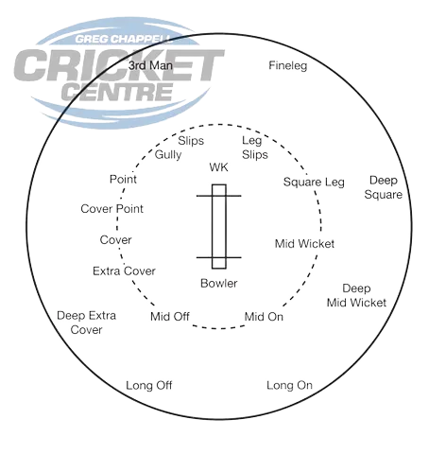
Captain’s Pointers
- Ensure each fielder is in the right spot following the diagram above (can adjust if needed).
- Encouraging each other and helping lift the energy in the field (walking in with the bowler).
- Ensuring bowlers are rotated (give the next bowlers 2-3 overs notice), and subs are rotated, per the tables on this document.
- Next bowler simply switches positions with the previous bowler.

