David Scott
Carina Cricket Club Life Member 08

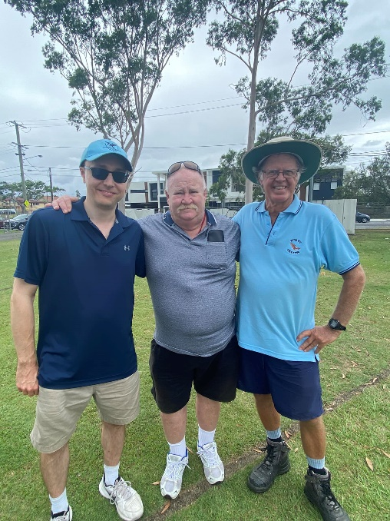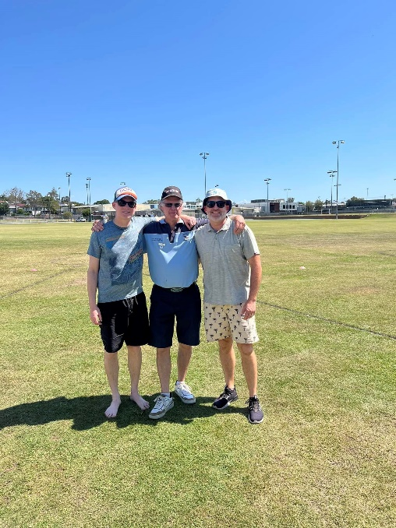

Many would regard David Scott as one of the club’s greatest ever members. Dave first joined the club in 1999 and soon joined the club’s committee, it wouldn’t be long before Dave took on the role of groundsman preparing wickets on not only Vince Herbert Oval but also Alan Ramsey Oval as the club had two grounds when Dave first started. His dedicated services as groundsman would continue for over 20 years allowing many members senior and junior to experience playing on quality turf wickets. Dave would prepare his final wicket for the club in 2023 (starting in 2000) and would then help oversee along with Simon Eggins the renovations of the outfield that winter.
Beyond his tireless efforts as groundsman where he would spend 20-25 hours a week at the club, Dave served as Vice-President under multiple Presidents one being his son Michael (Life Member 11).
In 2008, David was awarded Life Membership for his contributions to the club, so great is the mark he has left on the club, that the club’s annual Club Person of the Year Award is named after both him and Peter Wright, two men that set the standard for service given to Carina Cricket Club.
In 2024, the club now with it’s new wicket block and outfield held a tribute match for David with many members past and present including his family there to thank David Scott for all his contributions to the club, some pictures from the day are below.
