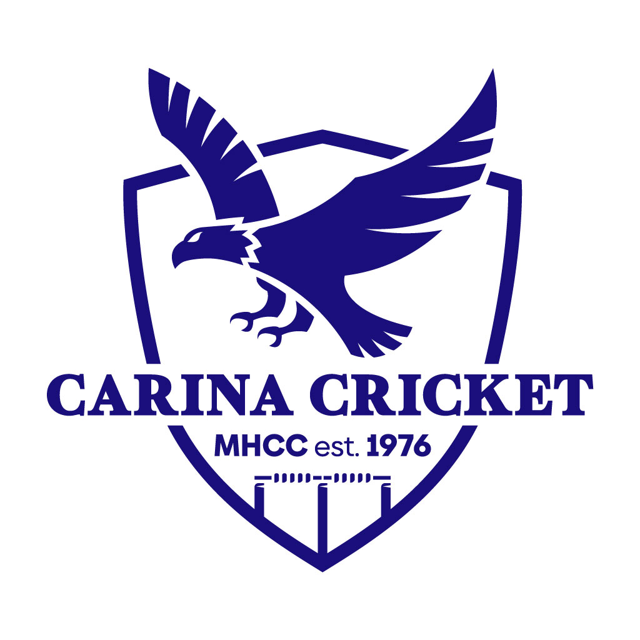

Carina Cricket Club U9-U10s TRAINING GUIDE
By Millan Agarwal
Coaching.director@carinacricketclub.com.au
0404692504

Contents

- Club philosophy of U9-10s.
- Key coaching and team management tips.
- Training outline.
- Ideas for net sessions.
- Bowling coaching (most important).
- Batting coaching.
- Fielding coaching.
- Other training ideas.

Club Philosophy

Enjoyment - players enjoying themselves and having fun. This is still very early in their cricket careers, so we want them to fall in love with the game.
Participation - equal opportunities for all players to learn and improve at the game.
Improvement – Players are better players at the end of the season than they are at the start of the season.
Connection - connecting with the player on a greater level than cricket and building that community atmosphere amongst the team and club. Have a social gathering as a team.

Coaching and Team Management Tips

- Make it fun – kids learn skills much easier if they are enjoying themselves
- Make activities competitive
- Ensure every activity has a clear purpose
- Keep the players involved and engaged – avoid doing activities where kids are standing around
- Plan our sessions
- Keep it simple
Training Sessions
Session length
75 minutes
75 minutes is a good length for training at this age group, we run the risk of being unproductive and players losing interest (keeping in mind they’ve had school already) if we go too long, however, some coaches may wish to do 90 minutes (makes up for players coming late or they have a super keen group).

Session Structure
5 minutes - warm up
35 minutes – field activities
35 minutes – nets activities
Warm Up (Refer to Warmups & Fielding Guide)
Dynamic warm up and warm up game.
Field activities (Refer to Warmups & Fielding Guide)
One fielding game – fun + competitive
One fielding drill – technique + purpose
One game sense drill – match simulation
Net Sessions (Refer to Batting & Bowling Skills and Drills Document)
Week 1 – Live net session where bowlers bowl to batters. Ensure the session has a clear for focus bowlers and batters. Can use ‘Upskilling Net Sessions’ document.
Week 2 – Live net session where bowlers bowl to batters. Ensure the session has a clear focus for bowlers and batters. Can use ‘Upskilling Net Sessions’ document.
Week 3 – Batting and bowling skills drills. Involve parents to help.
*Repeat three-week cycle for as many times as required

End of Training
Debrief the session – What did we focus on? What did we learn? What do we need remember for Saturday? Go through run sheet / order for Saturday, this means players go into game day knowing what to expect.

Live Net Sessions
How can we add purpose to our live net sessions?
- Targets for batters to hit that represent gaps.
- Bowling targets that don’t get in the way of batters.
- Wide cones, if bowlers bowl outside the wide cones, batters get free hit.
- Hitting along the ground game, batting team get points for along the ground, bowling team gets points for in the air.
- Bowling cones for alignment and technique.
- Refer to ‘Upskilling your Net Sessions’ document.
How can we make our live net sessions more effective?
- Have parents give throw downs in between bowlers to improve quality of balls batters get.
- Have a parent wicket keep to speed up returning balls back to the bowlers.
- Have a batting tee in the nets so if the batter faces a wide ball they may hit of the tee.

Skills to Teach
Batting Include Videos
- Teaching players how to hold the bat and what stance is required. https://youtube.com/shorts/GNHXQukTMjg?si=bsA_2pZP_7rvbY1p

- Getting players comfortable hitting a ball with a cricket bat, key coaching points are watching the ball, being stable (one step), and full bat swing, therefore, a lighter bat is best for beginners. Does not need to be straight bat at this stage. https://youtube.com/shorts/W4v0KemKxy4?si=ESCY5bOPOjcPWWPi

- Teaching batters to hit in different directions, footwork, head position, and different swing planes (straight bat and cross bat), straight, offside and leg side. Introduce the concept of straight bat. All front foot at this stage. https://youtube.com/shorts/vxy50h_YJuI?si=jb7VioNy3ZJ_Igx1

- Teaching players to hit along the ground and defend the good balls (introduces decision making). All front foot at this stage. https://youtube.com/shorts/NtNUNP2GCCI?si=hBrUKCBGR_Gn7D3P

- Running between the wickets – Yes, no, wait. How to turn correctly? Knowing when to run, sliding the bat, correct running technique. Backing up at the non-strikers end.
Backing up RBW - https://youtube.com/shorts/zQmpcrwg9t4?si=d9kWq32ifA1ZLWZE
Turning RBW - https://youtube.com/shorts/ok-M1J-LW2s?si=BQSw3yTJFwe7JqMY

- Teach players to use back foot. Pull shot, back foot drive, cut shot.
Pull shot basics - https://youtube.com/shorts/o--VklI-IkY?si=pT-gw8WEYhQyJDrw
Back foot drive - https://youtube.com/shorts/0v61ol1Ghj8?si=T38J_u2WYPZUIVWu
Cut shot - https://youtube.com/shorts/0IiLIMzyudI?si=xT208p4EaqINEZiq

Bowling Include Videos
- Bowling with a straight arm and being able to make the distance. https://youtube.com/shorts/oO0ussmjNzI?si=ri8olc9iyCHsXNIJ
- Ball grip. https://youtube.com/shorts/Ev1mcfGARUo?si=fBpQ4eM0gF0jtNYz
- Approach to the crease. https://youtube.com/shorts/eywallua83o?si=-zEhKTMcmyyZLdwl
- Alignment. https://youtube.com/shorts/cTk15yVeMjY?si=64ISrSLqxgxA_VWO
- Gather. https://youtube.com/shorts/u9EQjimYg5A?si=5H8hJV1Ofr1y7wAG
- Safe action. https://youtube.com/shorts/hfGSp4CyG4E?si=m-O0InaFhVKODyOM
- Front arm. https://youtube.com/shorts/bqkyZUbggKY?si=N_OdrJuNKINV9TY9
- Head position. https://youtube.com/shorts/V-dhU6NF-ZM?si=SYj9au2RnmxJGba4
- Follow through. https://youtube.com/shorts/EtD3t_0qfjQ?si=ZY9Ob43jOWp2SVnK
Where is the ideal place to bowl for different age groups?
U9s – U12s - At the stumps. Make the batter play as much as possible and bring in all forms of dismissal. Aim to bowl full.
Target bowling drills video –
Fielding Include Videos
- Catching. https://youtube.com/shorts/uU-S1PcxQUU?si=N0qZuUd4tzYdU73a
- High catching. https://youtube.com/shorts/GLJgtmLP6I4?si=a4zBeMKbZYaQHfSf
- Attacking ground fielding. https://youtube.com/shorts/W6JJ30bzPTU?si=3n8G0xOHXNt_c_7m
- Defensive ground fielding. https://youtube.com/shorts/WdRjLrOXApk?si=zifv9NsLjS_SCKfB
- Throwing. https://youtube.com/shorts/P1NKW9_tnUQ?si=XhSBxWuN7MKQjKPm
- Backing up. https://youtube.com/shorts/I_Yjkfk6MXU?si=PsstAwW8vKeXhxhv

Game Sense
Teaching players how a game of cricket works.
Understanding the game, backing up, fielding, positions and roles, hitting gaps, knowing when to run and not.
Other Training Ideas
Centre wicket session – play a game of pairs cricket where two players a bat (in pads) and the rest field and bowl, rotate every four overs, this allows the coach to help the players in actual game like environment, can organise a ground with a pitch via Coaching Director Millan Agarwal for this.
Field only session – Expanding the 35 minutes of field activities to the whole session, only do this sparingly.
Nets only session – Expanding the 35 minutes of nets activities to the whole session, only do this sparingly.
Parents vs kids cricket – Fun idea for last training session of the season.

