
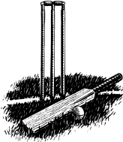 NOTICE OF 2026
ANNUAL GENERAL MEETING
for
Carina Cricket Club Inc
Saturday, 26 September 2026
6:30pm at the Carina Cricket Club Clubhouse.
Agenda Items:
- Approval of minutes of the previous general meeting.
- President’s Report, which will include information regarding the club’s operations throughout the year.
- Treasurer’s Report, which will include the receiving and presentation for adoption of the club’s financial statement and audit report for the last reportable financial year.
- Advice to members of the club’s public liability insurance.
- All positions will be declared vacant and election of members of the management committee will proceed.
- Appointment of the auditor.
- Appointment of the patron.
- Motion to accept life membership nomination of D Smith.
- Disclosure of any material personal interests of management committee members.
- Presentation of details of any remuneration paid or other benefits given for the financial year to management committee members and their relatives, and to senior employees of the club any of their relatives.
- General Business.

All Members Welcome

